
United States National Center for EPA/
Environmental Protection Environmental Assessment March, 2007
Agency Research Triangle Park, NC 27711
Research and Development

Ten Berge CxT Models

External Draft Version 1.0

Prepared by

National Center for Environmental Assessment
Office of Research and Development
U. S. Environmental Protection Agency
Research Triangle Park, N C 27711



NOTICE

The U.S. Environmental Protection Agency, through its National Center for Environmental Assessment at Research Triangle Park, produced this report. This document is a preliminary draft. It has not been formally released by the U.S. Environmental Protection Agency and should not be construed to represent Agency policy. It is circulated as a guide for reviewers of the model.
TABLE OF CONTENTS

AUTHORS
Authors

Qun He, Lockheed Martin, RTP, NC 27713

Bruce Allen, Lockheed Martin, RTP, NC 27713

Jeff Gift, National Center for Environmental Assessment, RTP, U.S. EPA, NC 27711

SECTION 1: INTRODUCTION
This report is intended to provide an overview of beta version 1.0 of the implementation of a concentration-time (CxT) model originally programmed and provided by Wil ten Berge (referred hereafter as the ten Berge model). The recoding and development described here represent the first steps towards integration of the ten Berge model into the EPA Benchmark Dose Software (BMDS). At present the software can be run from a Windows Command Prompt; at a later date it will be possible to invoke the ten Berge model from the beta interface for BMDS version 2.0.

In this introduction, the modeling needs and requirements are laid out first. This is followed by a description of the modeling framework and criteria for implementing the ten Berge model within the BMDS context, compared to the general structure of BMDS dichotomous models. Specific ten Berge model design issues (theoretical development, mathematical formulation and identification of data and parameter value inputs and constraints) and model coding are discussed in Section 2. In subsequent sections, the method of running the software is described (Section 3); the sample output is explained as an example of its use in a risk assessment (Section 4); and the approach for model testing, with preliminary test results, is provided (Section 5).

1.1 MODELING NEEDS AND REQUIREMENTS

CxT modeling has a long history of use in the assessment of acute exposure risks. The ten Berge version of CxT modeling was initially developed as a program coded in Visual Basic by Dr. Wil ten Berge. Dr. ten Berge graciously provided the source code, as well as the executable programs, to EPA so that they could be evaluated for possible inclusion in BMDS.

It was determined that the first step towards possible inclusion in BMDS would be a new version of the ten Berge model written in the C language, the language in which the other BMDS model code is written. Thus, the purpose of the task described herein was to develop models comparable to the ten Berge model, written in C, and suitable for integration into BMDS. The products of this task include the C source code, an executable program implementing that source code and yielding results that have been verified, and this manual documenting the achievement of those goals and specifying how to run the new program.

1.2 MODELING FRAMEWORK -- GENERAL OVERVIEW AND COMPARISON TO BMDS DICHOTMOUS MODELS

When the ten Berge model is incorporated into BMDS, it will represent a type of model unlike any other model currently in BMDS. That is because it incorporates more than one explanatory (independent) variable to define the dependent variable, which in this instance is the probability of some response of interest. In fact, the motivation for a model like the ten Berge model is to specifically allow both concentration (exposure level) and duration of exposure (time) to be determinants of the probability of response, hence the rubric “CxT model.”

Because the response variable is probability of response, the ten Berge is most similar to the dichotomous models that are included in BMDS. Those models also predict probability of response as a function of the explanatory variable (dose only in those models). In fact, the logit and probit link functions that are options for defining the relationship between concentration and time, on the one hand, and probability of response, on the other hand, in the ten Berge model are also options for BMDS modeling of dichotomous responses (albeit without the capability to factor in the duration of exposure). Section 2 describes the mathematical relationships in greater detail.

Because the response of interest is a probability (represented by observations consisting of the number of individuals who have the response of interest out of the total number of individuals examined) just like the BMDS dichotomous models, the following description of the likelihood approach to parameter estimation, which is true of the BMDS dichotomous models is also relevant to the ten Berge model.

Model Equations

BMDS dichotomous models can all be written in the form:

p(dose) = g(dose; α, β, …)

where p(dose) is the probability of response when the exposure level is equal to “dose.” The extension to the ten Berge model is that additional explanatory variables are included:

p(concentration, time, x) = h(concentration, time, x; α, β, γ, …)

where “x” represents some other explanatory variable(s) that the investigator might be interested in including. Here g(dose; α, β , . . .) or h(concentration, time, x; α, β, γ, …) is some function requiring the independent variables (dose or concentration, time and x) and α, β , . . ., as inputs; α, β, … are parameters to be estimated using maximum likelihood methods. Depending on the model function, g(α, β, …), chosen, the parameter values may be constrained. The options for the h(.) function for the ten Berge model are described in greater detail in Section 2.

Likelihood Function

All models in the current version of BMDS are fit using maximum likelihood methods. This is true of the ten Berge model as well. This section describes the likelihood function used to fit the dichotomous and ten Berge models.

Suppose the data set to be fit has k groups, each may have a dose level:

dose(1), dose(2), …, dose(k)

or, for CxT modeling, a set of explanatory variables such as

[conc(1), time(1), x(1)], [conc(2), time(2), x(2)], …, [conc(k), time(k), x(k)]

Suppose the total numbers of individuals in each of the groups are:

N(1), N(2), …, N(k)

If the observed numbers of individuals with the response of interest are:

n(1), n(2), …, n(k)

then, assuming the distribution of the n(i) is binomial, the log-likelihood of the data for a given dichotomous model is

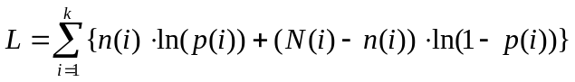

where p(i) = g(dose(i); α, β, …) or p(i) = h(conc(i), time(i), x(i); α, β, γ, …). In the ten Berge model and in the other dichotomous models, the parameters α, β, … are estimated by finding the values that maximize that log-likelihood.

BMD Computation

The ten Berge model does not compute BMDs as that terminology is used for other dichotomous BMDS models. In those other models, a BMD corresponds to some specified additional or extra risk value. Currently, the ten Berge model estimates the combinations of concentration and time (and potentially other parameters) that yield specified probabilities of response (not risks). On the other hand, the ten Berge model as the capability to calculate the response for specified concentration, time, and other parameter inputs. Additional details about the computation of those values and how the user may request the program to do so are provided in Sections 2 and 3.

SECTION 2: TEN BERGE MODEL: DESIGN AND CODING

2.1 THEORETICAL DEVELOPMENT
The idea that both concentration and duration of exposure may affect the likelihood of a toxic response, especially for short-term or acute exposures, has been common for some time. In fact, EPA’s software, CatReg, is a very flexible program for modeling the probability of response as a function of concentration and durations or exposure. CatReg can handle responses that have a graded severity scale, not just the 0/1 dichotomous responses that are treated in the ten Berge model.

2.2 MATHEMATICAL FORMULATION

In the discussion above (Section 1.2), the explanatory variables for the ten Berge model were “linked” to the probability of response via a Link function h(.). In this implementation of the ten Berge model, that function can take two forms:

Logit: h(z) = exp(z) / (1 + exp(z))
Probit: h(z) = (z-5)

where (y) is the cumulative standard normal distribution function evaluated at y. The term “z-5” is used in the probit link function rather than “z” itself for historical reasons having to do with the original definition of what a probit was and computational ease.

Moreover, the variable z in the equations above is actually a function of the explanatory variables of interest. If those explanatory variables are concentration (C), duration of exposure (T), and some other parameter (x), then

z = B₀ + B₁*f_{c}(C) + B₂*f_{t}(T) + B₃*f_{x}(x) + B₄*r₄(C, T, x) + B₅*r₅(C, T, x) + …

The terms B₀, B₁, B₂, … correspond to the α, β, γ, parameters discussed above (Section 1.2), the ones that are estimated via maximum likelihood methods and which determine the magnitude of the contribution of the explanatory variables for the probability of response. The functions f_{c}, f_{t}, and f_{x} are chosen by the user to be one of the following:

f_{i}(u) = u (identity transformation)
f_{i}(u) = ln(u) (logarithmic transformation)
f_{i}(u) = 1/u (reciprocal transformation)

The user may pick f_{c} independently of f_{t} and f_{x}; that is, the user may pick the logarithmic transformation for f_{c}, for example, without constraining f_{t} and f_{x}, which can then be any of the three possible transformations and might differ from one another. The r_{i}(C, T, x) terms represent products of a pair of the values f_{c}(C), f_{t}(T), and f_{x}(x); for example r₄(C, T, x) might be f_{c}(C)*f_{t}(T). If, for example, the logarithmic transformation of C was chosen, then the product term(s) that involved C would also have to be the logarithm of C times the chosen transformation of another parameter.

Note that the parameter “x” is actually a place holder for any number of possible explanatory variables of interest (think of x as a vector of variables). Thus, there may be many terms that could be added to the model at the user’s option, including all the individual variables represented by x, the products of pairs of terms in x, and the product of those terms with C and/or T. Currently, the one limitation on the number of product terms in the model is that it cannot exceed the total number of explanatory variables divided by 2 (rounded down). Thus, if C, T and x were in the model, and x consisted of a single term, there could be no more than floor(3/2) = 1 product terms. This limitation is a carry over from the original ten Berge model coding.

One particular model formation is may be of interest for acute exposure modeling, where often a C^{n}xT relationship is postulated, where n is some unknown power on concentration. If the logarithmic transformation is chosen for C and for T, then the term inside h(.) is (ignoring any contributions from other parameters represented in x)

B₀ + B₁*ln(C) + B₂*ln(T)
= B₀ + B₂*((B₁/B₂)*ln(C) + ln(T))
= B₀ + B₂*ln(C^{B1/B2} * T)
= B₀ + B₂*ln(C^{N} * T)

where N = B₁/B₂. Thus, a model that includes log-transformed C and T will have a term that can be equated to C^{N}xT (log-transformed) where N can be estimated by the ratio of the linear coefficients of ln(C) and ln(T). As discussed in the next section, the BMDS coding of the ten Berge model allows the user to request that such ratios be estimated.

2.2 PARAMETER ESTIMATION

As indicated above, for the selected model, the linear coefficients (the B_{i} terms) are estimated by maximum likelihood techniques. In particular, the maximization of the likelihood is done via the Taylor-McLaurin expansion and iterates estimates of the B_{i} terms, estimating dB_{i} via a system of linear equations involving dL/dB_{i} and d²L/dB_{i}dB_{j} terms until the dB_{i} are sufficiently close to zero. Here L is the log-likelihood function defined in Section 1.2.

Confidence intervals and tests of the significance of the B_{i} coefficients are estimated via Wald approximations using the variances and covariances of the B_{i}’s. Those variances and covariances are calculated using the estimated values of the inverse of the matrix of negative second derivatives.

The user may also request estimates and confidence limits for the following:

A value of one of the explanatory variables, given the values of the other explanatory variables and a probability of response (e.g., a concentration that, for a given duration of exposure, yields a probability of response of interest);
The probability of response, given the values of the all the explanatory variables (e.g., the probability of response for a specified concentration and duration);
The ratio between the coefficients of two explanatory variables (e.g., the ratio of the coefficients for ln(C) and ln(T), which was shown above to give an estimate of the parameter N in the C^{N}xT formulation).

The confidence limits in all of these cases are based on the variances estimated for the coefficients and use the Wald method for approximating the variances of functions of those parameters.

The user is required to input one parameter that determines the confidence level for calculation of all of the estimates discussed above. It is not the confidence level itself, but rather is a deviate corresponding to the confidence level of interest. It can be calculated and input by the user as follows.

First note that the degrees of freedom associated with a model applied to a chosen data set will be the number of observations in the data set (lines of data containing values of the possible explanatory variables and the measures of response) minus the number of B_{i} terms in the model. Thus, for example, if the data set contained 20 observations and the model of interest were to include C, T and sex (coded as a 0/1 variable), there would be 4 B_{i} terms in the model (1 for the intercept term, B₀, plus 1 for each of C, T and sex), so that there would be 16 degrees of freedom associated with that model and the data set in question.

When the fit of a model is evaluated, a sum of terms summarizing the squared difference between the observed probability of response and the model-predicted probability of response (normalized by the model-predicted variance associated with that prediction) is computed and compared to a chi-square distribution. The degrees of freedom associated with that chi-squared distribution is the degrees of freedom described in the previous paragraph. If the sum of squared differences is not too large (less than the 95th percentile of that chi-squared distribution), then the program determines that the fit is satisfactory.

When the fit is satisfactory, the recommended deviate corresponding to the confidence level of interest can be derived from the standard normal distribution. The two-sided critical value, corresponding to an α of the user’s choice, from the standard normal distribution can be used to derive the 100*(1-α) percent confidence interval. The following table gives the critical values (to be entered as the deviates for computation of confidence intervals) for some common choices of α:

Table 1: Deviates Corresponding to Confidence Levels of Interest for Confidence Interval Estimation (from Standard Normal Distribution)
α | Confidence Level | Deviate
0.2 | 80% | 1.282
0.1 | 90% | 1.645
0.05 | 95% | 1.960
0.01 | 99% | 2.576

The user can determine the deviate to use for other confidence levels of interest from a table of quantiles of a standard normal distribution, available in many elementary statistics books (or s/he may compute them using Microsoft Excel function “NORMSINV” and putting in (1-α/2) as the argument to that function when interest is in the 100*(1-α) confidence interval).

When the fit of the model is not deemed to be satisfactory, then the use of the standard normal distribution to derive the deviates is considered to underestimate the width of the desired confidence interval. To account for the uncertainty associated with the model fit, it is often recommended that a student-t distribution be used to obtain the deviates. The student-t deviates depend on the degrees of freedom associated with the model fit to the data set, and they tend to be larger (entailing wider confidence intervals) than the corresponding deviates from the standard normal distribution. The user will have to compute degrees of freedom before running the model (a simple calculation as described above) in order to input the deviate based on the appropriate student-t distribution. The following table gives the deviates corresponding to several possible degrees of freedom and desired confidence levels.

Table 2: Deviates Corresponding to Confidence Levels of Interest for Confidence Interval Estimation (from Student-t Distributions)
Degrees of Freedom | Confidence Level
Degrees of Freedom | 80% | 90% | 95% | 99%
5 | 1.476 | 2.015 | 2.571 | 4.032
10 | 1.372 | 1.812 | 2.228 | 3.169
15 | 1.341 | 1.753 | 2.131 | 2.947
20 | 1.325 | 1.725 | 2.086 | 2.845
30 | 1.310 | 1.697 | 2.042 | 2.750
40 | 1.303 | 1.684 | 2.021 | 2.704
60 | 1.300 | 1.671 | 2.000 | 2.660
80 | 1.292 | 1.664 | 1.990 | 2.639

Note that as the degrees of freedom get larger, the deviates approach the corresponding values from the standard normal distribution (Table 1). The user may calculate the deviates for other degrees of freedom and confidence levels by using the Microsoft Excel function “TINV” with the arguments equal to α, when a 100*(1-α) confidence interval is desired, and the degrees of freedom for the model fit to the data. Note also that, because the goodness of the fit of the model will not be known until after the model is run, the user can opt to just put in the student-t based deviates corresponding to their model and confidence level of choice up front (see the description of the input files in Section 3). The resulting confidence intervals will be conservative in the sense that they may be a little wider than might be needed to get the desired confidence level, but they can always be changed with later runs using the deviates from the standard normal distribution if the fit is satisfactory and if the user wishes to obtain slightly narrower confidence intervals.

2.4 MODEL CODING

C code was developed that implements the ten Berge model and computes the estimates of interest to the user. That code was a translation of the Visual Basic code originally developed by Wil ten Berge and graciously shared with EPA. The entire source code is presented in Appendix A.

SECTION 3: RUNNING THE MODEL FROM A WINDOWS COMMAND PROMPT

The current version of the ten Berge model software was built to run on a Windows platform, and at present the ten Berge model can only be run from a Command Prompt window.

When the Command Prompt window shows that you are in the directory containing the executable program (exponential.exe), type the following to execute the program on a data set of your choosing and produce an output file of the results:

tenberge input.(d)

where input.(d) can be the name of any suitably defined (d) file. The output of the run will be contained in a file called “input.out” where, again, the actual name of the (d) file used will precede the “.out” extension.

The (d) File Format

A sample of a (d) file with the appropriate format is given below. Only the values to the left are in the file; the numbers to the right are annotations so that a more complete explanation of the required inputs can be provided below the sample file. An unannotated version of this file is contained in Appendix B, which can be copied and pasted into an empty txt file and then edited (with Notepad for example) to create data sets for your particular application.

Annotated Example Exponential Model .(d) File:

3 ………………………………………………………………………………………………………… 1
68 ………………………………………………………………………………………………………… 2
Conc mg/m3 ………………………………………………………………………………………………………… 3
Minutes ………………………………………………………………………………………………………… 4
BW grams ………………………………………………………………………………………………………… 5
Exposed ………………………………………………………………………………………………………… 6
Dead ………………………………………………………………………………………………………… 7
952 15 200 10 1 ………………………………………………………………………………………………………… etc
1278 15 200 10 4
1403 15 200 10 6
1631 15 200 10 7
1767 15 200 10 9
2028 15 200 10 6
2349 15 200 10 9
653 30 200 10 0
886 30 200 10 0
1006 30 200 10 3
1033 30 200 10 6
1267 30 200 10 9
1359 30 200 10 10
435 60 200 10 0
544 60 200 10 1
653 60 200 10 4
740 60 200 10 8
544 15 23 10 2
707 15 23 10 4
903 15 23 10 7
946 15 23 10 7
1060 15 23 10 6
1153 15 23 10 9
1256 15 23 10 8
1658 15 23 10 9
1958 15 23 15 15
381 30 23 10 2
489 30 23 10 3
636 30 23 10 6
653 30 23 10 5
761 30 23 10 8
788 30 23 10 8
903 30 23 10 9
952 30 23 10 10
190 60 23 10 1
256 60 23 10 2
337 60 23 10 5
408 60 23 10 9
914 15 10000 4 0
1098 15 10000 4 1
1631 15 10000 4 2
1958 15 10000 4 2
2409 15 10000 4 4
555 30 10000 4 1
816 30 10000 4 2
1033 30 10000 4 2
1213 30 10000 4 3
1370 30 10000 4 3
1490 30 10000 4 4
343 60 10000 4 0
598 60 10000 4 1
696 60 10000 4 2
778 60 10000 4 4
924 60 10000 4 4
897 15 3700 4 0
1049 15 3700 4 1
1223 15 3700 4 3
1822 15 3700 4 3
2148 15 3700 4 3
1077 30 3700 4 0
1185 30 3700 4 2
1283 30 3700 4 4
631 60 3700 4 0
663 60 3700 4 1
761 60 3700 4 1
1028 60 3700 4 2
1169 60 3700 4 2
1213 60 3700 4 4
………………………………………………………………………………………………………… 8
modeling ………………………………………………………………………………………………………… 9
1 1 1 1 1 …………………………………………………………………………………………… 10, 11, 12, 13, 14
3 ………………………………………………………………………………………………………… 15
1 2 3 ………………………………………………………………………………………………………… 16,17,18
1 ………………………………………………………………………………………………………… 19
1 2 ………………………………………………………………………………………………………… 20, 21
1 68 ………………………………………………………………………………………………………… 22, 23
dose ………………………………………………………………………………………………………… 24
1 1.998 95 1 20 200 ………………………………………………………………………………………… 25,26,27,28,29,30
response ………………………………………………………………………………………………………… 31
1 1.998 500 20 200 ………………………………………………………………………………………… 32,33,34,35,36
ratio ………………………………………………………………………………………………………… 37
1 1.998 2 1 2 ………………………………………………………………………………………… 38,39,40,41,42
graph/response ………………………………………………………………………………………………………… 43
1 0.95 1 0 1000 2 20 3 200 ………………………………………………………………………………………… 44-52
end ………………………………………………………………………………………………………… 53

Annotation Notes:

1. Number of input parameters (possible explanatory variables). This number will be equal to the number of fields in an input record minus 2 (the last 2 being for the sample size and number responding).
2. Number of observations/data records. This number tells the program how many lines of data read (see the lines below labeled “etc.”
3. Name of the first input parameter. This name will be used to identify the variable considered to be input parameter 1.
4. Name of the second input parameter. This name will be used to identify the variable considered to be input parameter 2.
5. Name of the third input parameter. This name will be used to identify the variable considered to be input parameter 3. NOTE: there will be as many of these “name” lines as the number on line 1 (“Number of input parameters”).
6. Name of the parameter corresponding to the sample size. This name should indicate the total number of individuals examined for any given data record.
7. Name of the parameter corresponding to the number of individuals having the response of interest. This name may be used to indicate what that response is (e.g., “Dead” in this example).
etc. The data record lines. There should be exactly the same number of lines as the number on the second line of the input file (“Number of observations/data records”). The order of the fields must be the same on each line and must be exactly in the order given in the “Name” lines immediately preceding. And the last two fields on each line must correspond to the total number of individuals examined and the number responding, in that order.
8. Blank line. Include a blank line, with no spaces, tabs, or any other delimiter following the lines of data. This separates the data section from the user-specified modeling control sections.
9. The string “modeling.” Just the one string “modeling” should be on this line to indicate the section that defines the parameters and link functions that are to be included in the model.
10. Type of link function (see Section 2.2 above):
=1: Probit link function
= 2: Logit link function
11. Background response correction:
=1: No background response correction
=2: Background response correction
Currently, it is recommended that the user set this control parameter to 1 (no background response correction), as the other option has not been fully tested.
12. Transformation for input parameter 1. Even if the model subsequently defined (see items 15-21) does not include the first input parameter, a transformation for the parameter must be chosen. The identifiers for the 3 transformations included in this software are:
=1: logarithmic
=2: reciprocal
=3: identity (none)
13. Transformation for input parameter 2. Even if the model subsequently defined (see items 15-21) does not include the second input parameter, a transformation for the parameter must be chosen. The identifiers for the transformations are the same as for the first input variable (see item 12 above).
14. Transformation for input parameter 3. Even if the model subsequently defined (see items 15-21) does not include the third input parameter, a transformation for the parameter must be chosen. The identifiers for the transformations are the same as for the first input variable (see item 12 above). NOTE: It is possible to have more transformation identifies on this line. There should be one for each of the input parameters and so the number of them should be equal to the number on the first line of the input file (“Number of input parameters”).
15. Number of transformed input parameters to include in the model. This number must be less than or equal to the “Number of input parameters” field (item #1). It indicates the number of single (not product) terms to be included in the model. This value can be zero, but in that case the next line should be skipped altogether
16-18. The numbers corresponding to the input variables to be included in the model. These numbers correspond to the order in which those parameters were entered on the data record lines and to the order of the names given by items #2, #3, #4 (and possibly more) specified above. Remember, these input parameters will be entered into the model transformed however that parameter was specified to be transformed (see items #12-14). The total number of entries on this line will equal the number on the immediately preceding line (unless that number was zero in which case this line will be skipped entirely).
19. Number of product terms to include in the model. This integer must be less than or equal to the number of input parameters (item #1) divided by 2 (rounded down). It indicates the number of product terms to be included in the model. This number can equal zero, in which case the next line is skipped entirely.
20-21. The numbers corresponding to the input parameters included as product terms in the model. The numbers must be entered in pairs, the number of such pairs equaling the integer on the previous line (item #19) (unless the preceding number was zero in which case this line is skipped entirely). These numbers correspond to the order in which those parameters were entered on the data record lines and to the order of the names given by items #2, #3, #4 (and possibly more) specified above. Remember, these input parameters will be entered into the model transformed however that parameter was specified to be transformed (see items #12-14), even for the product terms. The input parameter identifier numbers used in the product terms need not be restricted to those used in the single-parameter terms of the model.
22. The first record number to be included in the analysis. This number must be greater than or equal to 1 and less than or equal to item #2 (number of observations in the data set). Together with the next item (#23), this allows the user to restrict attention to (model only) observations in a certain range of the entire data set.
23. The last record number to be included in the analysis. This number must be greater than or equal to the number given by item #22, and less than or equal to item #2 (number of observations in the data set). Together with the previous item (#22), this allows the user to restrict attention to (model only) observations in a certain range of the entire data set.
24. The string “dose.” Only the string “dose” should appear on the next line to indicate that the user wishes to calculate the value of one input parameter that, for specified values of the other input parameters gives a user-specified response value. If the user does not desire to do such a calculation, this line and the following line should be skipped entirely.
25. Confidence intervals calculated?
= 0 for no (even if this value =0, the remaining items on this line, items #26-30, should still be entered in the appropriate order)
= 1 for yes
26. Deviate corresponding to the confidence level of choice. See Section 2.2 for a more detailed description of how to select this deviate. Enter this value even if item #25 equals zero.
27. The response of interest. This is given as a percent and so can have values between 0 and 100. X percent response corresponds to a probability of response of X/100.
28. The number identifier corresponding to the input parameter the user wishes to estimate. That number identifier must be one of those included in the list given by items #16-18.
29-30. The values for the other input parameters. These are the values assumed to be known, or of interest, that are fixed, so that for the response of interest (item #27), one can determine what value of the input parameter given by the identifier in item #28) gives that response. The values entered here must be in the same order as given in items #16-18, except that the value for the parameter corresponding to the identifier given in item #28 will not be given (because that is the value to be estimated). For example, if parameters 1, 2, and 3 are entered in the model, and we wish to estimate the value of parameter 1 (Conc mg/m3 in our example data set) that give a response of 95% when Minutes is equal to 20 and BW grams is equal to 200, then the line in question will appear as shown above, with the value for Minutes (20) preceding the value for BW grams (200) because Minutes is the second input parameter and BW grams is the third input parameter.
31. The string “response.” Only the string “response” should appear on this line to indicate that the user wishes to calculate the response percentage for user-specified values of all the selected input parameters. If the user does not desire to do such a calculation, this line and the following line should be skipped entirely.
32. Confidence intervals calculated?
= 0 for no (even if this value =0, the remaining items on this line, items #33-36, should still be entered in the appropriate order)
= 1 for yes
33. Deviate corresponding to the confidence level of choice. See Section 2.2 for a more detailed description of how to select this deviate. Enter this value even if item #32 equals zero.

34-36. Values for the all the input parameters included in the model. These values should be entered in the order corresponding to their number identifier (e.g., in this example, the value for Conc mg/m3 first, followed by a value for Minutes, followed by a value for BW grams).

37. The string “ratio.” Only the string “ratio” should appear on this line to indicate that the user wishes to calculate the ratio of specified B_{i} coefficients estimated in the model. If the user does not desire to do such a calculation, this line and the following line should be skipped entirely.
38. Confidence intervals calculated?
= 0 for no (even if this value =0, the remaining items on this line, items #39-42, should still be entered in the appropriate order)
= 1 for yes

39. Deviate corresponding to the confidence level of choice. See Section 2.2 for a more detailed description of how to select this deviate. Enter this value even if item #38 equals zero.

40. Number of variables selected. This value should always be set equal to 2, as the ratio will be of the coefficients for two input parameters.

41-42. The number identifiers of the pair of coefficients for which the ratio is desired. As above, these number identifiers correspond to the order that the input parameters are entered in a data record. The identifiers must be from among the set of identifiers entered in items #16-18 (and any additional identifiers on that line) as input parameters used as single terms in the model.

43. The string “graph/response.” Only the string “graph/response” should appear on this line to indicate that the user wishes to produce plots of the model results. Currently, the graphical functions of this software are in development, so this line and the next merely indicate right now how such plotting will be done. If the user does not desire to do such plotting, this line and the following line should be skipped entirely.
44. Confidence intervals calculated?
= 0 for no (even if this value =0, the remaining items on this line, items #45-52, should still be entered in the appropriate order)

= 1 for yes

45. Deviate corresponding to the confidence level of choice. See Section 2.2 for a more detailed description of how to select this deviate. Enter this value even if item #44 equals zero.

46. X-axis variable. This is identified by identifier number as in the previous references to parameters.

47-48. The range for the x-axis. The response will be calculated and plotted for each value of the x-axis variable between item #47 and item #48.

49-52. In pairs, the identifier number and value to assume for the remaining input parameters included in the model. Each pair will have the identifier number for the parameter and the value to assign to that parameter when the plots are created. There will be as many pairs as there are input parameters included in the model.

53. The string “end.” Only the string “end” should appear on this line to indicate that the program has reached the end of the input file. This must be the last line of each input file.

SECTION 4. MODEL RUN EXAMPLE

The following dose-response data summary is an example of a data set that might be obtained from a set of experiments in several species, where the animals were exposed to a concentration of a compound (in mg/m³) for variable durations of time (in minutes). The species are “identified” by their body weights (in grams). In this instance the toxic response of interest was death, as indicated by the response parameter name. There were a total of 68 observations (data records). This is the data set that was used to create the example .(d) file shown above in Section 3.

Table 3: Example Dose-Response Data Set
Conc mg/m3 | Minutes | BW grams | Exposed | Dead
952 | 15 | 200 | 10 | 1
1278 | 15 | 200 | 10 | 4
1403 | 15 | 200 | 10 | 6
1631 | 15 | 200 | 10 | 7
1767 | 15 | 200 | 10 | 9
2028 | 15 | 200 | 10 | 6
2349 | 15 | 200 | 10 | 9
653 | 30 | 200 | 10 | 0
886 | 30 | 200 | 10 | 0
1006 | 30 | 200 | 10 | 3
1033 | 30 | 200 | 10 | 6
1267 | 30 | 200 | 10 | 9
1359 | 30 | 200 | 10 | 10
435 | 60 | 200 | 10 | 0
544 | 60 | 200 | 10 | 1
653 | 60 | 200 | 10 | 4
740 | 60 | 200 | 10 | 8
544 | 15 | 23 | 10 | 2
707 | 15 | 23 | 10 | 4
903 | 15 | 23 | 10 | 7
946 | 15 | 23 | 10 | 7
1060 | 15 | 23 | 10 | 6
1153 | 15 | 23 | 10 | 9
1256 | 15 | 23 | 10 | 8
1658 | 15 | 23 | 10 | 9
1958 | 15 | 23 | 15 | 15
381 | 30 | 23 | 10 | 2
489 | 30 | 23 | 10 | 3
636 | 30 | 23 | 10 | 6
653 | 30 | 23 | 10 | 5
761 | 30 | 23 | 10 | 8
788 | 30 | 23 | 10 | 8
903 | 30 | 23 | 10 | 9
952 | 30 | 23 | 10 | 10
190 | 60 | 23 | 10 | 1
256 | 60 | 23 | 10 | 2
337 | 60 | 23 | 10 | 5
408 | 60 | 23 | 10 | 9
914 | 15 | 10000 | 4 | 0
1098 | 15 | 10000 | 4 | 1
1631 | 15 | 10000 | 4 | 2
1958 | 15 | 10000 | 4 | 2
2409 | 15 | 10000 | 4 | 4
555 | 30 | 10000 | 4 | 1
816 | 30 | 10000 | 4 | 2
1033 | 30 | 10000 | 4 | 2
1213 | 30 | 10000 | 4 | 3
1370 | 30 | 10000 | 4 | 3
1490 | 30 | 10000 | 4 | 4
343 | 60 | 10000 | 4 | 0
598 | 60 | 10000 | 4 | 1
696 | 60 | 10000 | 4 | 2
778 | 60 | 10000 | 4 | 4
924 | 60 | 10000 | 4 | 4
897 | 15 | 3700 | 4 | 0
1049 | 15 | 3700 | 4 | 1
1223 | 15 | 3700 | 4 | 3
1822 | 15 | 3700 | 4 | 3
2148 | 15 | 3700 | 4 | 3
1077 | 30 | 3700 | 4 | 0
1185 | 30 | 3700 | 4 | 2
1283 | 30 | 3700 | 4 | 4
631 | 60 | 3700 | 4 | 0
663 | 60 | 3700 | 4 | 1
761 | 60 | 3700 | 4 | 1
1028 | 60 | 3700 | 4 | 2
1169 | 60 | 3700 | 4 | 2
1213 | 60 | 3700 | 4 | 4

Appendix C contains the output file produced by running the ten Berge model on this data set. That is, Appendix C is the result of typing “tenberge example.(d)” at a Windows Command Prompt if the dose-response data shown in the above table are represented in the file called “example.(d),” which is created in accordance with the instructions shown in Section 3, and is in fact the very input file that is shown in Appendix B.

The output file shown in Appendix C has been color coded for ease of reference and explanation of the various sections of that output. Details related to that output are provided here, referenced by color-coded section.

Reference Model Information: This section merely gives information about the version number and build date of the program, as well as identifying the input data set used to create the output and the name of the file (“example.plt” in this example) that has the information needed to later produce graphics. One of the most important pieces of information in this section may be the date and time at which the model was run. This may be important to keep track of the latest version of the output, should changes and corrections be made. At present, if the model is run using an input file having the same name as an input file previously run, the earlier output file will be over-written.

Model Specifications: This section provides the overview of the framework for the model, including the reference for Finney (1977) from which Wil ten Berge identified the probit analysis approach. The general form of the model as it is now implemented is presented here as is a basic summary of the number of input parameters (possible explanatory variables) and the number of observations in the data set.

Input Data Set Echo: This section should contain exactly the data that the user has included in the input file. If there are any errors here, the user should go back to the input file and correct the input values, and then rerun the analysis.

Modeling Choices: In this section, the following information is provided: the choices for the range of observations to analyze, the transformations of the input parameters to use, the link function (logit or probit), and the variable identifier numbers associated with the selected explanatory variables (single input parameters or products of pairs of input parameters). If any of this information does not correspond to the desired analysis, the user must go back to the input file to make corrections to the coding in the modeling section.

Fit and parameter estimates: The chi-square evaluation of fit and the degrees of freedom associated with the model fit to the selected data are given. The maximum likelihood estimates of the B_{i} coefficients are shown as is a Student t value that can be used to determine whether each of those terms is “statistically significant.” Variance and covariance estimates for each of the B_{i} terms are provided.

“Dose” estimation: In this section one finds the estimate of an input parameter value that, for a given response and for specified values of the other input parameters, gives that response rate. In this example, the response was set to 95% and the Minutes and BW grams variables were set to 20 and 200, respectively. For those Minutes and BW grams values, the model estimates that that the Conc mg/m3 needed to get 95% response is 2228. Because a deviate corresponding to a confidence level was given (1.998, which is the student-t deviate associated with 95% confidence level, where there are 63 degrees of freedom) the lower and upper bounds on that Conc mg/m3 estimate are also shown). The values (1860 and 3054 mg/m³, respectively) can be taken as the 95% confidence interval for the concentration giving 95% chance of death when the exposure duration is 20 minutes and the BW of the animal is 200 grams.

Response Estimation: Much like the previous section, this section provides estimates of the response associated with specified values of the input variables used in the model. When a deviate is given, the corresponding confidence interval is also calculated for that estimate. Note that the deviate supplied need not be the same as the one provided for the “dose” estimation, in case different confidence levels may be desired for dose and response estimates. In this example, the response estimated to be associated with 500 mg/m³ exposure, lasting 20 minutes, in an animal weighing 200 grams is 9.52%, and the 95% confidence interval for that estimate is 3.38% to 21.4%.

Ratio Estimation: In this section the ratio of the Bi coefficients request by the user will be reported. As in the previous sections the confidence interval is also shown, if requested, at a level consistent with the specified deviate. Here the ratio of the coefficients for Conc mg/m3 and Minutes is estimated to be approximately 1.50, with 95% confidence interval extending from

-1.43 to 4.45. Recall from the above presentation (Section 2.2) that the ratio of the coefficient for the concentration term to the coefficient for the duration term is an estimate of the exponent N in the C^{N}xT relationship, when ln(C) and ln(T) are the transformations used in the model (as they are here). In this particular example, the model also includes the term ln(C)*ln(T) (the product specified and identified with variable 4). Thus, the interpretation of the ratio B₁/B₂ as an estimate of N might be problematic and might account for the fact that the lower bound on B₁/B₂ is negative. Of course, the user could always re-run the model opting not to include the product of transformed concentration and transformed duration. It is left as an exercise for the reader to see what happens in that case (remember to change the degrees of freedom when determining the deviate to use for 95% confidence limit calculations).

SECTION 5. MODEL TESTING

5.1 TESTING METHODS
The basis for testing the C-code implementation of the ten Berge model was the Visual Basic version of that model provided by Wil ten Berge. Executable version number 4 of his model was used to derive estimates of the parameter values (including Student-t values, variances, and covariances), chi-squared fit estimates, degrees of freedom, dose estimates for a given response, response estimates for a given set of input parameters, and coefficient ratio estimates, for 3 data sets. The values produced by his program were then used as the standard against which the C-code implementation was compared.

Note that this test merely confirms that the new model code yields the same estimates as the old ten Berge model from which it was translated. Since the first task towards getting code that can be integrated into BMDS is to successfully translate existing working models into code that can be used for that integration, such a test is adequate for our purposes. The new program has not, however, been tested against an independent program that could be configured to run the same models. At some point, such a test, perhaps using EPA’s CatReg software as the independent implementation might be desirable.

5.2 TESTING RESULTS
Figure 1a shows the screen shot of the original (Visual Basic) ten Berge model parameter estimates for the example.(d) data set. This is the screen obtained when the “calculate” option is chosen from the drop down menu under “Estimation” on the toolbar, after having made the selections that match those shown in example.(d) and echoed in example.out. For example, the selections for that data set include picking the probit link function, logarithmically transforming all the parameters, and selecting all of them to be in the model. Moreover, Figures 1b, 1c, and 1d show, respectively, the screen shots for that run corresponding to “dose at response,” “response at dose,” and “ratio regression coeff.” choices under the “Evaluation” option on the toolbar. The corresponding set of Figures (2a-2d, and 3a-3d) are shown for runs on data sets example2.(d) and example3.(d), respectively. These are the standards against which the new code outputs were compared.

Appendix C displays the output file produced by the new code for the first data set (shown above in Table 3). Appendix D shows the data set (as part of the input file) and an output file produced by the new code when run on the example2.(d) data set; Appendix E shows a third data set, example3.(d) and the corresponding output file. Thus, Appendix C outputs correspond to those shown in Figures 1a-1d. Appendix D outputs correspond to those shown in Figures 2a-2d. Appendix E outputs correspond to those shown in Figures 3a-3d. The choice of link function, the parameters included in the model, the transformations, and the responses and doses estimated were varied from one data set to another (see descriptions in the corresponding output files) to ensure that the desired options were operating correctly.

Comparison of the corresponding figures and output files from the appendices shows that the executable from the new code and the executable obtained from Wil ten Berge match exactly on all of the parameters listed in Section 5.1.

These preliminary test results suggest that the conversion of the ten Berge model to C code that can eventually be used to incorporate CxT modeling into BMDS has been successfully accomplished.

Figures

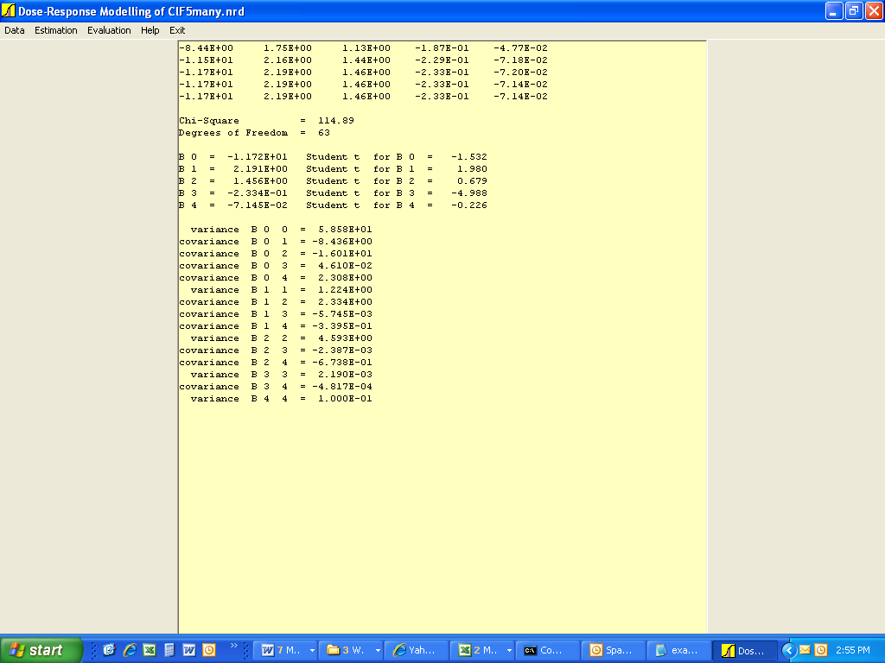
Figure 1a: ten Berge Visual Basic run on example.(d) data set. Coefficient estimates and chi-square.

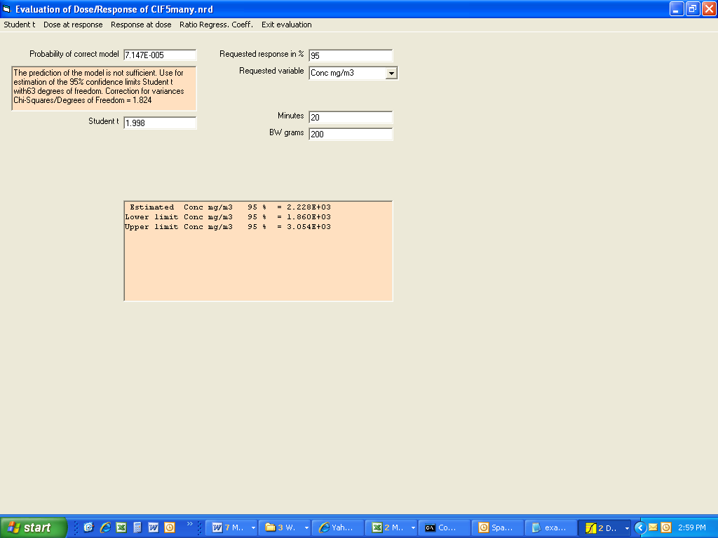
Figure 1b: ten Berge Visual Basic run on example.(d) data set. Concentration estimate corresponding to 95% response rate, for selected values of Minutes and BW grams.

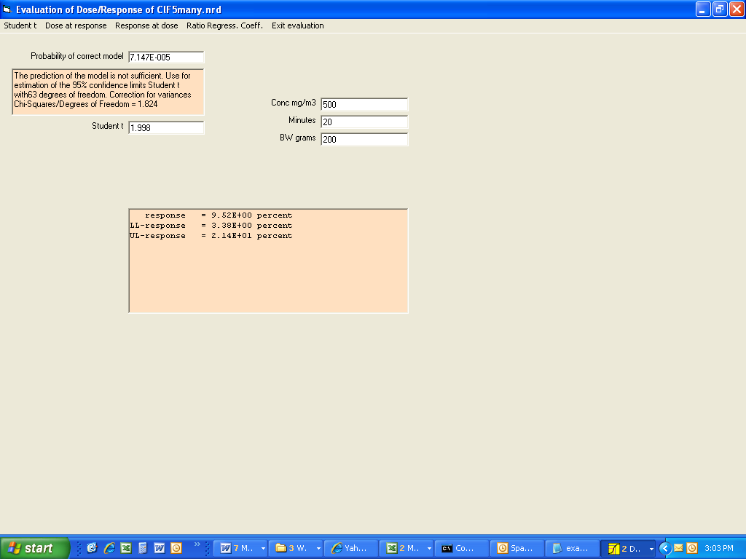
Figure 1c: ten Berge Visual Basic run on example.(d) data set. Response estimate for selected values of Conc mg/m3, Minutes, and BW grams.

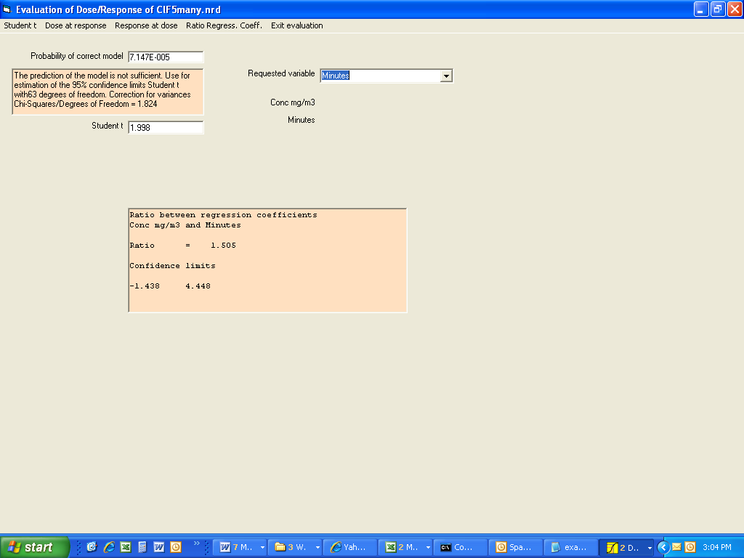
Figure 1d: ten Berge Visual Basic run on example1.(d) data set. Ratio of coefficients of Conc mg/m3 and Minutes.

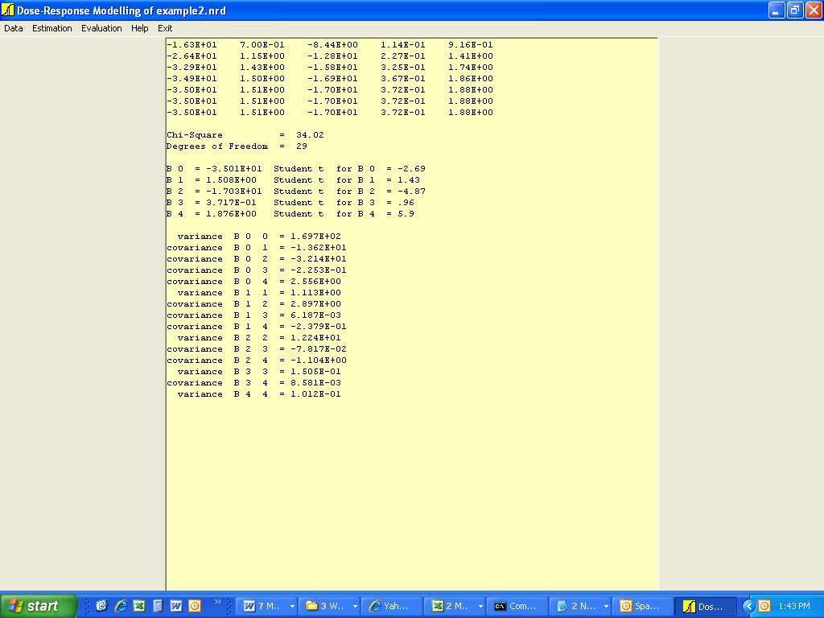
Figure 2a: ten Berge Visual Basic run on example2.(d) data set. Coefficient estimates and chi-square.

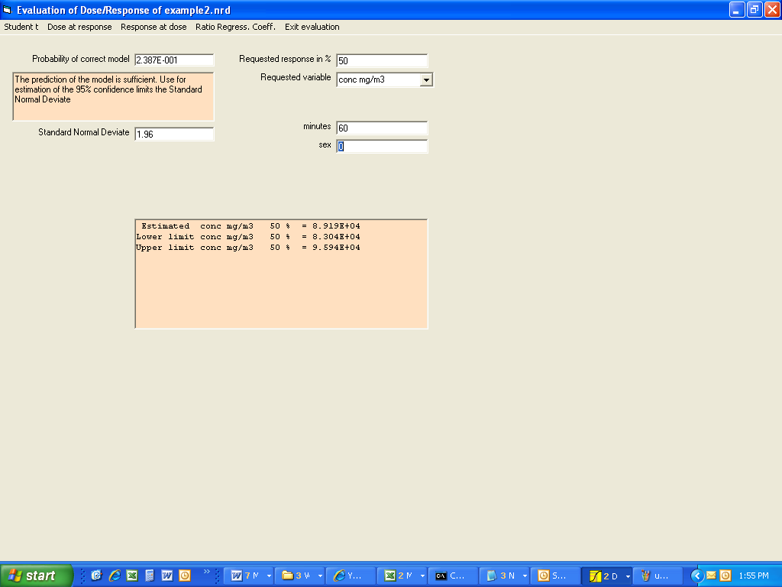
Figure 2b: ten Berge Visual Basic run on example2.(d) data set. Concentration estimate corresponding to 50% response rate, for selected values of minutes and sex.

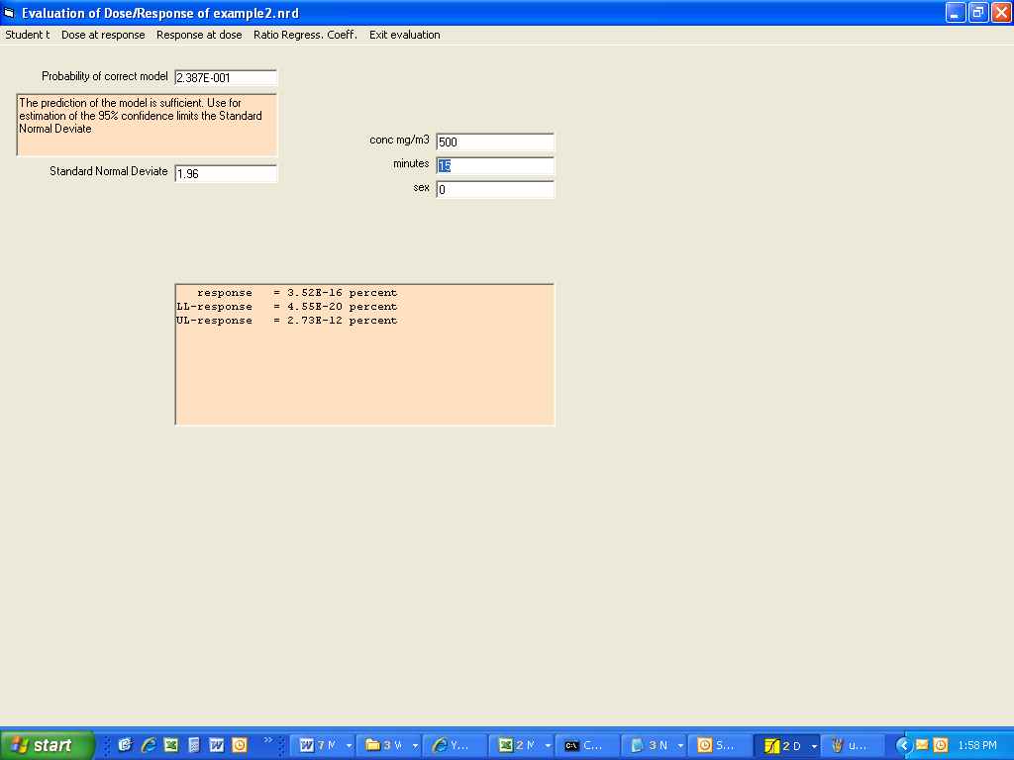Figure 2c: ten Berge Visual Basic run on example2.(d) data set. Response estimate for selected values of conc mg/m3, minutes, and sex.

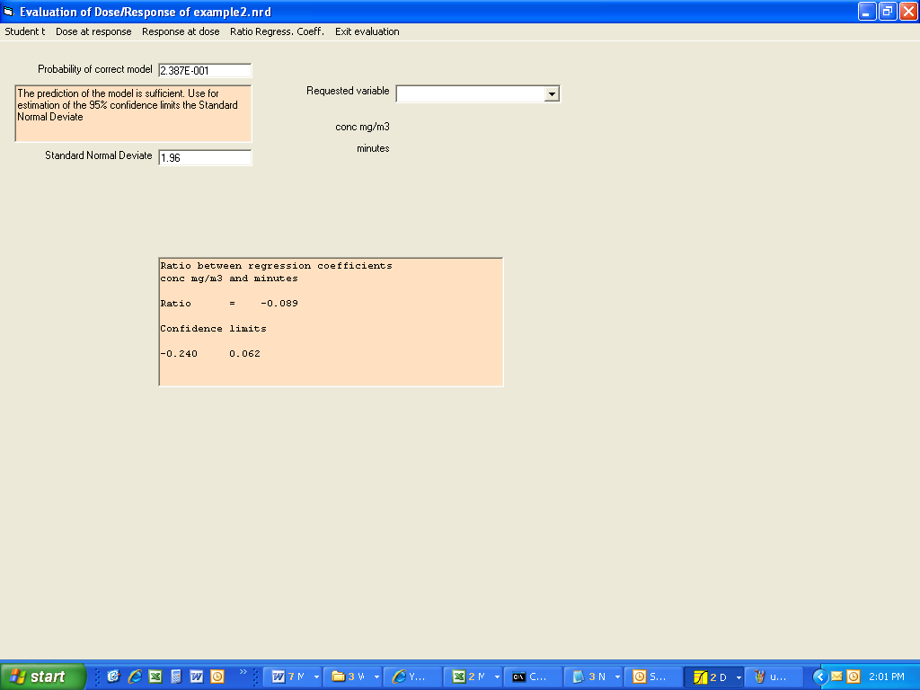
Figure 2d: ten Berge Visual Basic run on example2.(d) data set. Ratio of coefficients of conc mg/m3 and minutes.

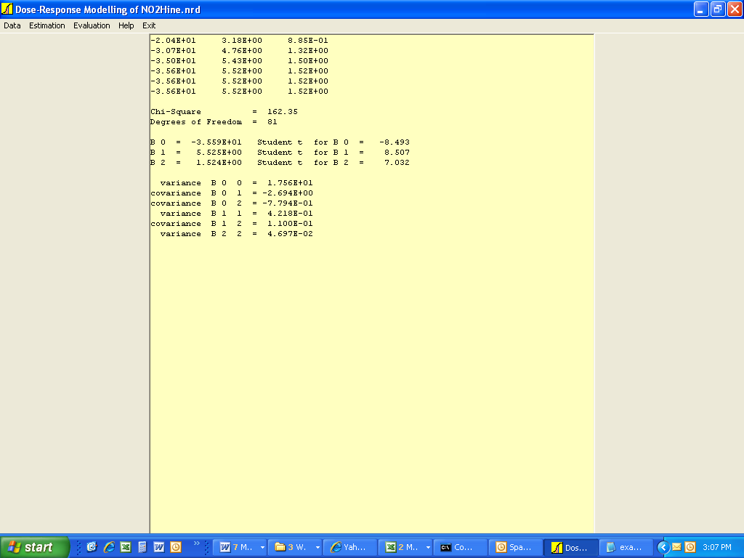
Figure 3a: ten Berge Visual Basic run on example3.(d) data set. Coefficient estimates and chi-square.

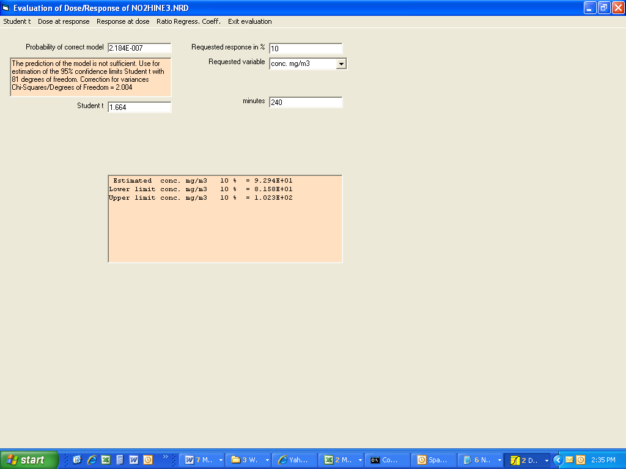
Figure 3b: ten Berge Visual Basic run on example3.(d) data set. Concentration estimate corresponding to 10% response rate, for selected value of minutes.

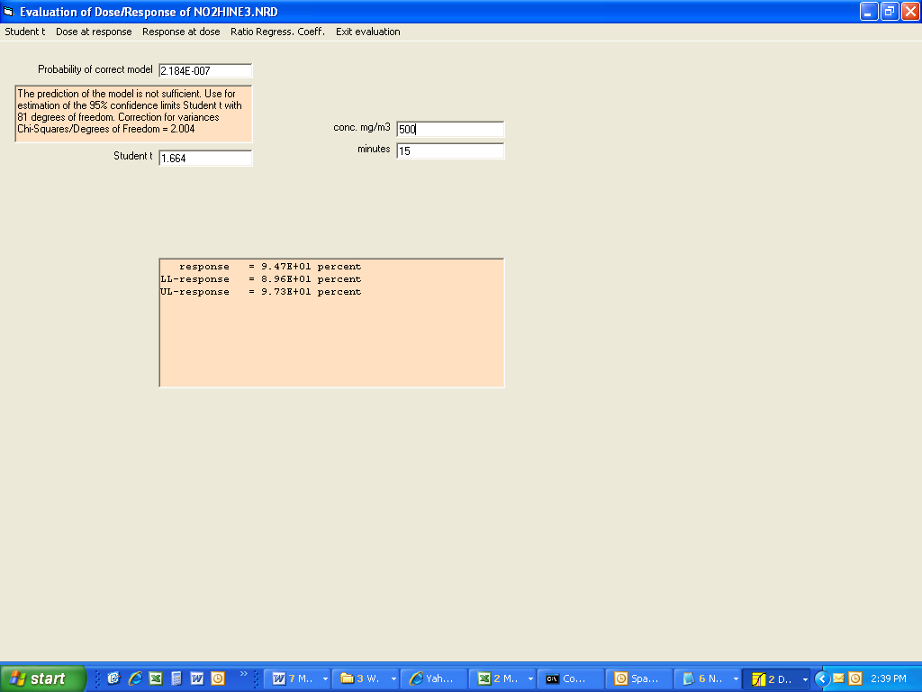
Figure 3c: ten Berge Visual Basic run on example3.(d) data set. Response estimate for selected values of conc mg/m3 and minutes.

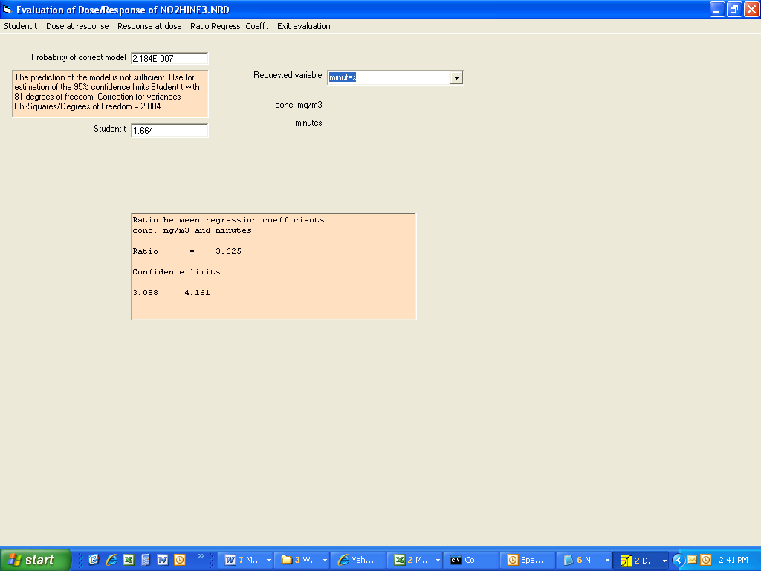
Figure 3d: ten Berge Visual Basic run on example3.(d) data set. Ratio of coefficients of conc mg/m3 and minutes.
APPENDIX A. TEN BERGE MODEL SOURCE CODE

// *******************************************************************************
// Converted to C from VisualBasic program of Dosresp (Dose-Response Analysis)
// software (W.F. ten Berge, Nov. 2001) without the visual components
//
// by Qun He (12/26/2006)
// ****************************************************************

// ***********************************************************************
// General information of the model
// ***********************************************************************

char Version_no[] = "Ten Berge Model. (Version: 1.0; Date: 12/26/2006)";
char Model_info[] = "Dose-Response Analysis\n\n Method of Maximum Likelihood according to: \
\n D.J. Finney, 1977. Probit Analysis. Cambridge University Press.";
char Formula[] = "Model: P(v1, v2, ...) = Link(B0 + B1*v1 + B2*v2 + ...)\n \
\n Link is either Logit or Probit \
\n v1, v2, ... are the variables (transformations of the input parameters)\n";

// ********************************************
// Header files
// ********************************************
#include <windows.h> // Win32 Header File
#include <windowsx.h> // Win32 Header File
#include <commctrl.h> // Win32 Header File
#include <mmsystem.h> // Win32 Header File
#include <shellapi.h> // Win32 Header File
#include <shlobj.h> // Win32 Header File
#include <richedit.h> // Win32 Header File
#include <wchar.h> // Win32 Header File
#include <objbase.h> // Win32 Header File
#include <ocidl.h> // Win32 Header File
#include <winuser.h> // Win32 Header File
#include <olectl.h> // Win32 Header File
#include <conio.h>
#include <direct.h>
#include <ctype.h>
#include <io.h>
#include <math.h>
#include <stdio.h>
#include <string.h>
#include <stddef.h>
#include <stdlib.h>
#include <setjmp.h>
#include <time.h>
#include <stdarg.h>
#include <process.h>

#include <benchmark.h>
#include <ERRORPRT.h>
#include <allo_memo.h>
#include <matrix_agb.h>
#include <specialfun.h>
#include <computation.h>
#include <in_outfun.h>

// *************************************************
// System Variables
// *************************************************

char BCX_STR [1024*1024];
jmp_buf GosubStack[32];
int GosubNdx;
#define DEBUG 1;

// *************************************************
// User Global Variables
// *************************************************

static int I;
static int J;
static int SW;
static FILE* FP2;
static FILE* logfile;
static FILE* response;

#define NUMOFVAR 14; /* See variable Vrx[][] */
#define LENOFNAME 20; /* See variable Vrx[][] */

int NZ; /* No. of variables */
int NW; /* No. of observations */
int NY; /* No. of selected single transformed variable for analysis */
int NC; /* No. of pairs of product of transformed variables */
int NX; /* Total No. (selected single variable + selected pair of variables) */
int KBZ; /* (1=without; 2=with) background response correction */
int KPZ; /* (1=Probit; 2=Logit) model */
int KZ, KZY, HQ, MQ, NXT;
int NB; /* Flag of error in transform variables */
int MV; /* Index of requested variable for evaluation */
int NS, MX, DF;
int N1; /* First sequence number of trials for analysis */
int N2; /* Last sequence number of trials for analysis */
int TW;
int NXC; /* No. of variables selected for product analysis */
double CH; /* Chi-Squares value */
double CX; /* Correction for variances (Chi-Squares/Degrees of Freedom) */
double ZM, P;
double PW; /* Requested response in percentage (set to 50 when user specify <= 0) */
double Q, SQ, Y, Z;
double XZ;
double TX; /* Value of Student t set by user */
double CZ, DC, DW;
double AW, BW, CW, Cy, RA, RB;
int K0[10]; /* List of selected single transformed variable for analysis */
int K1[5]; /* List of the left variables for the product analysis */
int K2[5]; /* List of the right variables for the product analysis */
int WF[12];
int NT[10]; /* List of variables' type of transformation (logrithmic, reciprocal, none) */
double XU[10]; /* List of transformed values for each variable */
double XW[10], PA[10];
double AX[10], BX[10], FX[10];
double ZA[10][10], BV[10][10], ZC[10][10], ZB[10];
int TR; /* Number of variables chosen for ratio regression coefficient evaluation */
int NRC1; /* First variable chosen for ration regression coefficient evaluation */
int NRC2; /* Second variable chosen for ration regression coefficient evaluation */
int FlEr; /* Error flag */
char Fina[128]; /* Input file name */
int *N; /* No. of subjects array */
int *LR; /* No. of responders array */
double **X; /* Input data matrix */
char Vrx[14][40]; /* Input data column names */
char conc_col[20];
char expos_time_col[20];
char subj_prop_col[20];
char num_expos_col[20];
char num_respd_col[20];
char comment_line[128];
int num_missing_value; /* No. of records with missing values */
int stdchisqr; /* Flag indicates Chisquare() calculated */
int chisqr_skip = 1; /* Flag the print out of Chisquare() calculattion */
time_t ltime;

// *************************************************
// Define input and output files's name
// *************************************************

char fout[128]; /* output temp file */
char fout2[128];
char plotfilename[128]; /* file to send to GnuPlot */
char infilestem[128]; /* input file name stem */
char respgraphfile[128]; /* graphics file name */

// *************************************************
// Standard Macros
// *************************************************

#define VAL(a)(double)atof(a)

// *************************************************
// Standard Prototypes
// *************************************************

char* BCX_TmpStr(size_t);
char* str (double);
char* join (int, ... );
double Abs (double);
double Exp (double);

// *************************************************
// User's Prototypes
// *************************************************

void RetrDat (void);
void SuPPDat (void);
void Filcomb3 (void);
void nrm21 (int);
void nrm22 (void);
void nrm23 (void);
void nrm24 (void);
void nrm25 (int);
void nrm26 (void);
void nrm28 (void);
void nrm29 (void);
void pqa (void);
void pqb (void);
void matrinv (double A[10][10], double B[10][10]);
void matrix (double A[10][10], double B[10], double C[10]);
void CalcML (void);
void CalcDoseResponse(void);
void CalcResponseDose(void);
void CalcResponseGraph(void);
void Graphic2(double Dx, double *Px1, double *Px2, double *Px3, double SV[]);
void CalcRatio(void);
void nrm41 (int);
void nrm42 (void);
void nrm43 (void);
void nrm44 (void);
void Chisquare (void);
void Warn1 (double QZ);
void Warn2 (double QZ);
void WriDat (void);
void CalcErr (void);
void check_args(int argc, char *argv[]);
void OPEN_FILES(int argc, char *argv[]);
void read_modeling_data(void);
int READ_OBSDATA (int r, int c, double **m);
void output_read_data(void);
void CLOSE_FILES(void);
void calML_H1(void);
void NRM2BGR(void);
void Get_File_Stem(char *argv, char *infilestem);
void Derive_File_Name(char *stem, char *newfile, const char *ext);

int check_data_sectors(const char *sector);

// *************************************************
// Main Program
// *************************************************

int main(int argc, char *argv[])
{
char sector[20];
int compare;
time(&ltime);

check_args(argc, argv);
Get_Names(argv[1], fout, fout2, plotfilename); /* get input and output file names */
Get_File_Stem(argv[1], infilestem); /* get input file name stemp */
Derive_File_Name(infilestem, respgraphfile, "Asc");/* derive graphics file name from infile stem */
OPEN_FILES(argc, argv); /* open output files */
read_modeling_data(); /* read input file */

Output_Header(Version_no, argv[1], plotfilename, ctime(&ltime), Model_info);
output_read_data(); /* output some input data */

CalcML();
WriDat();

fscanf(fp_in, "%s", sector);
compare = check_data_sectors(sector);

while (compare != 0) {
if (compare == 1)
CalcDoseResponse();
else if (compare == 2)
CalcResponseDose();
else if (compare == 3)
CalcRatio();
else if (compare == 4)
CalcResponseGraph();

fscanf(fp_in, "%s", sector);
compare = check_data_sectors(sector);
}

FREE_IVECTOR (N,1,NW);
FREE_IVECTOR (LR,1,NW);
FREE_DMATRIX(X, 1, NW, 1, NZ+2);
CLOSE_FILES(); /* close all opened files */

return 0;
} /* End of main program */

// *************************************************
// Run Time Functions
// *************************************************

char *BCX_TmpStr (size_t Bites)
{
static int StrCnt;
static char *StrFunc[2048];
StrCnt=(StrCnt + 1) & 2047;
if(StrFunc[StrCnt]) free (StrFunc[StrCnt]);
return StrFunc[StrCnt]=(char*)calloc(Bites+128,1);
}

char *str (double d)
{
register char *strtmp = BCX_TmpStr(16);
sprintf(strtmp,"% .15G",d);
return strtmp;
}

char * join(int n, ...)
{
register int i = n, tmplen = 0;
register char *s_;
register char *strtmp = 0;
va_list marker;
va_start(marker, n); // Initialize variable arguments
while(i-- > 0)
{
s_ = va_arg(marker, char *);
tmplen += strlen(s_);
}
strtmp = BCX_TmpStr(tmplen);
va_end(marker); // Reset variable arguments
i = n;
va_start(marker, n); // Initialize variable arguments
while(i-- > 0)
{
s_ = va_arg(marker, char *);
strtmp = strcat(strtmp, s_);
}
va_end(marker); // Reset variable arguments
return strtmp;
}

double Exp (double arg)
{
return pow(2.718281828459045,arg);
}

double Abs (double a)
{
if(a<0) return -a;
return a;
}

// ************************************
// User Functions
// ************************************

void check_args(int argc, char *argv[]) {
if(argc == 2)
show_version(argv[1], Version_no);

if(argc < 2) {
fprintf(stderr, "ERROR: Requires two arguments\nUsage: %s <file.(d)>\n", argv[0]);
fprintf (stderr, " or: %s -v for version number.\n", argv[0]);
exit (1);
}
}

int check_data_sectors(const char *sector)
{
int compare = strcmp("end", sector);

if (compare == 0)
return 0;

compare = strcmp("dose", sector);

if (compare == 0)
return 1;

compare = strcmp("response", sector);

if (compare == 0)
return 2;

compare = strcmp("ratio", sector);

if (compare == 0)
return 3;

compare = strcmp("graph/response", sector);

if (compare == 0)
return 4;
}

// *****************************************************
// OPEN_FILES--used to open input and output files.
// *****************************************************

void OPEN_FILES (int argc, char *argv[]) {
logfile = fopen("log.txt", "a"); /* open log file */
fp_in = fopen(argv[1], "r"); /* open input file */

// open output files
fp_out = fopen(fout, "w"); /* overwrite output */
fp_out2 = fopen(fout2, "w"); /* always overwrite plotting file */

// check to make sure files are open, if not, print error message and exit
if (fp_in == NULL || fp_out == NULL || fp_out2 == NULL) {
fprintf(logfile, "Error in opening input and output files.");
ERRORPRT ("Error in opening input and output files.");
}

response = fopen(respgraphfile, "w"); /* open response graph file */
}

// *****************************************************
// CLOSE_FILES--used to close input and output files.
// *****************************************************

void CLOSE_FILES (void) {
if (fclose(fp_in) != 0 || fclose(fp_out) != 0 || fclose(fp_out2) != 0) {
fprintf(logfile, "Error in closing opened files.");
fclose(response);
fclose(logfile);
ERRORPRT ("Error in closing opened files.");
}

fclose(response);
fclose(logfile);
}

void read_modeling_data () {
char junk[255];
fscanf(fp_in, "%d", &NZ); /* begin reading input from input .(d) file */
fscanf(fp_in, "%d", &NW);
fgets(junk, 128, fp_in); /* to get the junk out of the previous line */

int i;
Vrx[0][0] = 0;
for (i = 1; i < 14; i++) {
if (i <= NZ + 2) {
fgets(Vrx[i], 40, fp_in);
Vrx[i][strlen(Vrx[i]) - 1] = 0; /* strip carriage return */
} else {
Vrx[i][0] = 0;
}
}

#ifdef DEBUG
fprintf(logfile, "\n########################### %s\n", ctime(&ltime));
fprintf(logfile, "Reading data from input .(d) file...\n\n");
fprintf(logfile, "number of variables: %d \n", NZ);
fprintf(logfile, "number of observations: %d \n", NW);
fprintf(logfile, "concentration column: %s \n", Vrx[1]);
fprintf(logfile, "exposure time: %s \n", Vrx[2]);
fprintf(logfile, "subject property: %s \n", Vrx[3]);
fprintf(logfile, "number of exposed: %s \n", Vrx[4]);
fprintf(logfile, "number of reponded: %s \n", Vrx[5]);
#endif

N = IVECTOR(1, NW);
LR = IVECTOR(1, NW);
X = DMATRIX (1, NW, 1, NZ); /* init data variables */
num_missing_value = READ_OBSDATA(NW, NZ, X);

#ifdef DEBUG
fprintf(logfile, "\n\nNumber of missing value = %d\n", num_missing_value);
fprintf(logfile, "Reading input data file finished.\n");
#endif

fscanf(fp_in, "%s", comment_line);
fscanf(fp_in, "%d%d", &KPZ, &KBZ);

for (i = 1; i <= NZ; i++) {
fscanf(fp_in, "%d", &NT[i]);
}

fscanf(fp_in, "%d", &NY);

for(i = 1; i <= NY; i++) {
fscanf(fp_in, "%d", &K0[i]);
}

fscanf(fp_in, "%d", &NC);

for(i = 1; i <= NC; i++) {
fscanf(fp_in, "%d%d", &K1[i], &K2[i]);
}

fscanf(fp_in, "%d%d", &N1, &N2); /* first & last sequence number of trials for analysis */

#ifdef DEBUG
fprintf(logfile, "\n\nUser selections\n");
fprintf(logfile, "%s\n", comment_line);
fprintf(logfile, "KPZ=%d\n", KPZ);
fprintf(logfile, "KBZ=%d\n", KBZ);
fprintf(logfile, "NT[1]=%d\n", NT[1]);
fprintf(logfile, "NT[2]=%d\n", NT[2]);
fprintf(logfile, "NT[3]=%d\n", NT[3]);
fprintf(logfile, "NY=%d\n", NY);
fprintf(logfile, "K0[1]=%d\n", K0[1]);
fprintf(logfile, "K0[2]=%d\n", K0[2]);
fprintf(logfile, "K0[3]=%d\n", K0[3]);
fprintf(logfile, "NC=%d\n", NC);
fprintf(logfile, "K1[1]=%d\n", K1[1]);
fprintf(logfile, "K2[1]=%d\n", K2[1]);
fprintf(logfile, "N1=%d\n", N1);
fprintf(logfile, "N2=%d\n", N2);
#endif
}

void output_read_data(void) {
fprintf(fp_out, "\n %s", Formula);
fprintf(fp_out, "\n\n Number of input parameters = %d", NZ);
fprintf(fp_out, "\n Total number of observations = %d", NW);
fprintf(fp_out, "\n Total number of records with missing values = %d\n\n", num_missing_value);

fprintf(fp_out2,"\n\n Model calculations done.");
}

void nrm21 (int JM)
{
NB = 0;
int IV;
for(IV = 1; IV <= NZ; IV++) {
if (NT[IV] == 1) {
if (X[JM][IV] == 0) {
NB = 1;
return;
} else {
XU[IV] = log(X[JM][IV]);
}
}

if (NT[IV] == 2) {
if (X[JM][IV] == 0) {
NB = 1;
return;
} else {
XU[IV] = 1 / X[JM][IV];
}
}

if (NT[IV] == 3) {
XU[IV] = X[JM][IV];
}

#ifdef DEBUG
fprintf(logfile, "X[%d][%d]=%f XU[%d]=%f\n", JM, IV, X[JM][IV], IV, XU[IV]);
#endif
}//end for(IV = 1; IV <= NZ; ++IV)
}

void nrm22 (void)
{
int IW, NQ;

if (NY == 0) {
return;
}

for (IW = 1; IW <= NY; IW++) {
NQ = K0[IW];
XW[IW] = XU[NQ];
}
}

void nrm23 (void)
{
int IX, H1, H2;

if (NC == 0) {
return;
}

for (IX = 1; IX <= NC; IX++) {
H1 = K1[IX];
H2 = K2[IX];
XW[NY+IX] = XU[H1] * XU[H2];
}
}

void nrm24 (void)
{
int I, J;
for(I = MX; I <= NXT; I++) {
for(J = MX; J <= NXT; J++) {
ZA[I][J] = 0;
}

ZB[I] = 0;
}

CH = 0;
NS = 0;
CX = 0;
}

void nrm25 (int JM)
{
int H, K;

if (KBZ == 1) {
RA = N[JM] / (P * Q);
RB = (LR[JM] + 0.0) / N[JM] - P; /* we don't realy want a int / int result */

#ifdef DEBUG
fprintf(logfile, "RA=%f RB=%f N[%d]=%d LR[%d]=%d P=%f Q=%f\n", RA, RB, JM, N[JM], JM, LR[JM], P, Q);
#endif
} else if(KBZ == 2) {
RA = N[JM] / (PW * Q * SQ);
RB = (LR[JM] + 0.0) / N[JM] - PW;
}

CH = CH + RA * pow(RB,2);
#ifdef DEBUG
fprintf(logfile, "CH=%f\n", CH);
#endif
NS += 1;

for(H = MX; H <= NXT; H++) {
for(K = MX; K <= NXT; K++) {
//ZA[H][K] = ZA[H][K] + RA * PA[H] * PA[K];
ZA[K][H] = ZA[K][H] + RA * PA[H] * PA[K];
}

ZB[H] = ZB[H] + RA * RB * PA[H];
}
}

void nrm26 (void)
{
int I, J;

for (I = MX; I <= NXT; I++) {
for (J = MX; J <= NXT; J++) {
ZC[J][I] = ZA[J][I];
}
}
}

void nrm28 (void)
{
int I;
ZM = 0;

for(I = MX; I <= NXT; I++) {
BX[I] = BX[I] + FX[I];
ZM = ZM + Abs(FX[I] / BX[I]);
//fprintf(fp_out,"\n BX[%d]=%f",(int)I, BX[I]);
}

CX = 1;
DF = NS - NXT + MX - 1;
}

void nrm29 (void)
{
//print out
}

void pqa (void)
{
double S;

if (KPZ == 1) {
S = 1 / (1 + 0.2316419 * Abs(Y));
Z = Exp(-(pow(Y,2)) / 2) / sqrt(6.283185307);
P = Z * (S * 0.31938153 - pow(S,2) * 0.356563782 + pow(S,3) * 1.781477937 - pow(S,4) * 1.821255978 + pow(S,5) * 1.330274429);

if (Y > 0) {
P = 1 - P;
}
} else if (KPZ == 2) {
P = Exp(Y) / (Exp(Y) + 1);
Z = P * (1 - P);
}
}

void pqb (void)
{
double QT, TQ, AQ, BQ;
QT = PW / 100;

if (KPZ == 1) {
if (QT > 0.5) {
QT = 1 - QT;
}

TQ = sqrt(log(1 / pow(QT,2)));
AQ = 2.515517 + 0.802853 * TQ + 0.010328 * pow(TQ,2);
BQ = 1 + 1.432788 * TQ + 0.189269 * pow(TQ,2) + 0.001308 * pow(TQ,3);
Y = TQ - AQ / BQ;

if (PW < 50) {
Y = -Y;
}

} else if (KPZ == 2) {
Y = log(QT / (1 - QT));
}
}

void matrinv (double A[10][10], double BZ[10][10])
{
int HA, HB, HS, HX, HY, I, J;
double G;

#ifdef DEBUG
fprintf(logfile, "\n\nmatrinv function:\n");
#endif

for(I = MX; I <= NXT; I++) {
for(J = MX; J <= NXT; J++) {
BZ[J][I] = 0;
if(I == J) {
BZ[J][I] = 1;
}
}
}

HS = 1;
HA = MX;
HB = NXT - 1;

for(HY = 1; HY <= 2; HY++) {
#ifdef DEBUG
fprintf(logfile, "HS=%d\n", HS);
fprintf(logfile, "HY=%d\n", HY);
#endif

for(HX = HA; HS >= 0 ? HX <= HB : HX >= HB; HX += HS) {
#ifdef DEBUG
fprintf(logfile, "HX=%d\n", HX);
#endif

for(I = HX+HS; HS >= 0 ? I <= HB+HS : I >= HB+HS; I += HS) {
#ifdef DEBUG
fprintf(logfile, "I=%d\n", I);
fprintf(logfile, "A[%d][%d]=%f\n", HX, HX, A[HX][HX]);
#endif

if(A[HX][HX] != 0) {
//G = -A[I][HX] / A[HX][HX];
G = -A[HX][I] / A[HX][HX];
for(J = MX; J <= NXT; J++) {
//A[I][J] = A[I][J] + G * A[HX][J];
//BZ[I][J] = BZ[I][J] + G * BZ[HX][J];
A[J][I] = A[J][I] + G * A[J][HX];
BZ[J][I] = BZ[J][I] + G * BZ[J][HX];
}
}
}
}

HS = -1;
HA = NXT;
HB = MX + 1;
}

for(I = MX; I <= NXT; I++) {
G = A[I][I];

for(J = MX; J <= NXT; J++) {
//A[I][J] = A[I][J] / G;
//BZ[I][J] = BZ[I][J] / G;
A[J][I] = A[J][I] / G;
BZ[J][I] = BZ[J][I] / G;
}
}
}

void matrix (double A[10][10], double B[10], double C[10])
{
int K, L, HM, I, J;
double D, E, U, UH;

for (I = MX; I <= NXT; I++) {
C[I] = 0;
}

for (I = MX; I <= NXT - 1; I++) {
UH = A[I][I];
HM = I;

for (K = I+1; K <= NXT; K++) {
//if (Abs(UH) < Abs(A[K][I])) {
if (Abs(UH) < Abs(A[I][K])) {
HM = K;
}
}

if (HM != I) {
for (K = MX; K <= NXT; K++) {
//U = A[HM][K];
//A[HM][K] = A[I][K];
//A[I][K] = U;
U = A[K][HM];
A[K][HM] = A[K][I];
A[K][I] = U;
}

U = B[HM];
B[HM] = B[I];
B[I] = U;
}

for (K = I+1; K <= NXT; K++) {
if (Abs(A[I][I]) > 0) {
//D = A[K][I] / A[I][I];
D = A[I][K] / A[I][I];
}

for (L = MX; L <= NXT; L++) {
//A[K][L] = A[K][L] - D * A[I][L];
A[L][K] = A[L][K] - D * A[L][I];
}

B[K] = B[K] - D * B[I];
}
}

for (I = NXT; I >= MX; I--) {
E = 0;

for (K = MX; K <= NXT; K++) {
//E = E + C[K] * A[I][K];
E = E + C[K] * A[K][I];
}

if (Abs(A[I][I]) > 0) {
C[I] = (B[I] - E) / A[I][I];
}
}
}

void CalcML (void)
{
int I, J, TRX;
TRX = 0;

if (N1 < 1 || N2 > NW || N2 < N1){
return;
}

NX = NY + NC;

if(NX == 0){
return;
}

MX = 0;
XW[0] = 1;

if(KBZ == 1){
NXT = NX;
}

if(KBZ == 2){
NXT = NX + 1;
}

#ifdef DEBUG
fprintf(logfile, "\n\nKBZ=%d MX=%d NXT=%d\n", KBZ, MX, NXT);
#endif

for(I = 0; I <= NX; I++){
BX[I] = 0;
}

if(KPZ == 1){
BX[0] = 5;
}

BX[NX + 1] = 0.01;

for (I = 0; I < 10; I++) {
#ifdef DEBUG
fprintf(logfile, "Initital BX[%d]=%f\n", I, BX[I]);
#endif
}

do {
//fprintf(fp_out, "\nCalML called %d times. ZM=%f", TRX, ZM);
nrm24();
SQ = 1 - BX[NX + 1];

for(J = N1; J <= N2; J++) {
if(KBZ == 1) {
nrm21(J);
calML_H1();
Q = 1 - P;

for(I = 0; I <= NX; I++) {
PA[I] = Z * XW[I];
}
} else if(KBZ == 2) {//end if(KBZ == 1)
nrm21(J);
if(NB == 1) {
P = 0;
Z = 0;
} else {
calML_H1();
}
NRM2BGR();
}//end if(KBZ == 2)

nrm25(J);
}//end for(J = N1; J <= N2; ++J)

nrm26();
matrix(ZA, ZB, FX);
nrm28();
TRX += 1;
//fprintf(fp_out, "\nAt loops end - CalML called %d times. ZM=%f", TRX, ZM);
} while (TRX <= 100 && ZM >= 0.0001); //end while(TRX <= 20 && ZM >= .0001)

matrinv(ZC, BV);
Chisquare();
nrm29();

#ifdef DEBUG
fprintf(logfile, "\n\nCalcML() finished.\n");
#endif

return;
}

void calML_H1(void) {
nrm22();
nrm23();
Y = -5;

if(KPZ == 2) {
Y = 0;
}

for(I = 0; I <= NX; I++) {
Y = Y + BX[I] * XW[I];
}

pqa();
}

void NRM2BGR(void) {
Q = 1 - P;
PW = BX[NX + 1] + P * SQ;

for(I = 0; I <= NX; I++) {
PA[I] = Z * XW[I] * SQ;
}

PA[NX + 1] = Q;
}

void CalcDoseResponse(void)
{
int i, j, IQ, JQ;
int Plus = 0;
int student; /*Student t indicator*/

fscanf(fp_in, "%d%lf%lf%d", &student, &TX, &PW, &MV);

for (i = 1; i <= NY; i++) {
if (K0[i] == MV)
Plus = 1;
}

for (i = 1; i <= NC; i++) {
if (K1[i] == MV || K2[i] == MV)
Plus = 1;
}

if (Plus == 0)
return;

for (i = 1; i <= NZ; i++)
XU[i] = 0; /* initialize XU[3] */

for (i = 1; i <= NY; i++) {
for (j = 1; j <= NZ; j++) {
if (K0[i] == j) {
XU[j] = j;
}
}
}

for (i = 1; i <= NC; i++) {
for (j = 1; j <= NZ; j++) {
if (K1[i] == j || K2[i] == j) {
XU[j] = j;
}
}
}

for (i = 1; i <= NZ; i++) {
if (i != MV && XU[i] != 0)
fscanf(fp_in, "%lf", &XU[i]);
}

if (PW <= 0)
PW = 50;

if (student == 1) {
Chisquare();
} else {
TX = 0;
}

fprintf(fp_out, "\n Estimation of %s", Vrx[MV]);
fprintf(fp_out, "\n Response\t = %lf percent", PW);

pqb();

if (KPZ == 1)
Y = Y + 5;

AX[0] = BX[0] - Y;

for (i = 1; i <= NX; i++)
AX[i] = BX[i];

XU[MV] = 1;

for (i = 1; i <= NZ; i++) {
if (i != MV && XU[i] != 0) {
fprintf(fp_out, "\n %s\t = %lf", Vrx[i], XU[i]);
nrm41(i);
}
}

nrm22();
nrm23();

XW[0] = 1;
AW = 0;
BW = 0;
CW = 0;
XZ = 0;
Cy = 0;

for (i = 0; i <= NX; i++) {
IQ = 0;

if (i > 0 && i < NY + 1)
IQ = K0[i];

MQ = i;
nrm42();

if (IQ == MV && HQ == 1) {
Cy += AX[i];
goto nrm4c;
}

if (HQ == 2) {
Cy += AX[i] * XW[i];
goto nrm4c;
}

XZ = XZ - AX[i] * XW[i];

nrm4c:
for (j = 0; j <= NX; j++) {
JQ = 0;

if (j > 0 && j < NY + 1)
JQ = K0[j];

if (HQ == 2)
goto nrm4d;

MQ = j;
nrm42();

nrm4d:
CZ = (AX[i] * AX[j] - pow(TX, 2) * BV[j][i] * CX) * XW[i] * XW[j];

if (HQ == 1) {
if (IQ != MV && JQ != MV)
CW += CZ;

if (IQ == MV && JQ != MV)
BW += CZ;

if (JQ == MV && IQ != MV)
BW += CZ;

if (IQ == MV && JQ == MV)
AW += CZ;
}

if (HQ == 2) {
if (IQ != MV && JQ != MV && i != j)
BW += CZ;
else
AW += CZ;
}
}
}

XZ = XZ / Cy;
fprintf(fp_out, "\n\n Estimated %s %lf percent = ", Vrx[MV], PW);
nrm43();

if (student == 1)
fprintf(fp_out, " Deviate Corresponding to Confidence Level of Interest = %f\n", TX);

if (DF == 0) {
char Msg1[] = "number of degrees of freedom = ";
char Msg2[] = "Confidence limits cannot be calculated!";
fprintf(stderr,"\n%s%d\n%s\n", Msg1, DF, Msg2);
fprintf(fp_out,"\n %s%d\n%s\n", Msg1, DF, Msg2);

return;
}

DC = pow(BW, 2) - 4 * AW * CW;

if (DC <= 0) {
char Msg1[] = "95% confidence limits cannot be calculated!";
char Msg2[] = "Try a smaller Student t or standard normal";
char Msg3[] = "deviate with smaller confidence probability!";
fprintf(stderr,"\n%s\n%s\n%s\n", Msg1, Msg2, Msg3);
fprintf(fp_out,"\n %s\n%s\n%s\n", Msg1, Msg2, Msg3);

return;
}

DW = sqrt(DC);
XZ = (-BW - DW) / (2 * AW);
fprintf(fp_out," Lower limit %s %lf percent = ", Vrx[MV], PW);
nrm43();

XZ = (-BW + DW) / (2 * AW);
fprintf(fp_out," Upper limit %s %lf percent = ", Vrx[MV], PW);
nrm43();
}

void CalcResponseDose(void)
{
int I, J;
double VY, SY, Y1;
int student; /*Student t indicator*/

if (NX == 0)
return;

fscanf(fp_in, "%d%lf", &student, &TX);

for (I = 1; I <= NZ; I++)
XU[I] = 0; /* initialize XU[3] */

for (I = 1; I <= NY; I++) {
for (J = 1; J <= NZ; J++) {
if (K0[I] == J) {
XU[J] = J;
}
}
}

for (I = 1; I <= NC; I++) {
for (J = 1; J <= NZ; J++) {
if (K1[I] == J || K2[I] == J) {
XU[J] = J;
}
}
}

for (I = 1; I <= NZ; I++) {
if (XU[I] != 0)
fscanf(fp_in, "%lf", &XU[I]);
}

if (student == 1) {
Chisquare();
} else {
TX = 0;
}

fprintf(fp_out, "\n Estimation of response");

for (I = 1; I <= NZ; I++) {
if (XU[I] != 0)
fprintf(fp_out, "\n %s\t = %lf", Vrx[I], XU[I]);

nrm41(I);
}

nrm22();
nrm23();

XW[0] = 1;
VY = 0;
Y = 0;

if (KPZ == 1)
Y = -5;

for (I = 0; I <= NX; I++) {
for (J = 0; J <= NX; J++)
VY += XW[I] * XW[J] * BV[J][I] * CX;
Y += BX[I] * XW[I];
}

SY = sqrt(VY);
Y1 = Y;

pqa();
fprintf(fp_out, "\n\n Response = ");
nrm44();

if (student == 1)
fprintf(fp_out, " Deviate Corresponding to Confidence Level of Interest = %f\n", TX);

if (DF == 0) {
fprintf(fp_out, " Degrees of freedom = 0");
return;
}

Y = Y1 - TX * SY;

pqa();
fprintf(fp_out, " LL-response = ");
nrm44();

Y = Y1 + TX * SY;

pqa();
fprintf(fp_out, " UL-response = ");
nrm44();

return;
}

void CalcResponseGraph(void)
{
double Wdx, Dx, DX1, DX2;
double Px1, Px2, Px3;
double SV[NZ];
int student; /*Student t indicator*/
int index;

fscanf(fp_in, "%d%lf%d%lf%lf", &student, &TX, &MV, &DX1, &DX2);

if (student == 0)
TX = 0;

for (I = 1; I <= NZ; I++)
SV[I] = 0; /* initialize XU[3] */

for (I = 1; I <= NY; I++) {
for (J = 1; J <= NZ; J++) {
if (K0[I] == J) {
SV[J] = J;
}
}
}

for (I = 1; I <= NC; I++) {
for (J = 1; J <= NZ; J++) {
if (K1[I] == J || K2[I] == J) {
SV[J] = J;
}
}
}

for (I = 1; I <= NZ; I++) {
if (SV[I] != 0 && I != MV) {
fscanf(fp_in, "%d%lf", &index, &SV[I]);
}
}

Wdx = DX2 - DX1;

if (Wdx <= 0)
return;

if (DX1 = 0)
DX1 = Wdx / 100;

Graphic2(DX1, &Px1, &Px2, &Px3, SV);

for (Dx = DX1; Dx <= DX2; Dx += Wdx/100) {
Graphic2(Dx, &Px1, &Px2, &Px3, SV);

fprintf(response, " %f", Dx);
fprintf(response, " %f", Px1);
fprintf(response, " %f", Px2);
fprintf(response, " %f\n", Px3);
}
}

void Graphic2(double Dx, double *Px1, double *Px2, double *Px3, double SV[])
{
int I, J;
double SY, VY, Y1;

for (I = 1; I <= NZ; I++) {
if (MV == I)
XU[I] = Dx;
else
XU[I] = SV[I];

nrm41(I);
}

nrm22();
nrm23();

XW[0] = 1;
VY = 0;
Y = 0;

if (KPZ == 1)
Y = -5;

for (I = 0; I <= NX; I++) {
for (J = 0; J <= NX; J++ )
VY += XW[I] * XW[J] * BV[J][I] * CX;

Y += BX[I] * XW[I];
}

SY = sqrt(VY);
Y1 = Y;

pqa();

*Px1 = P;

if (DF == 0)
return;

Y = Y1 - TX * SY;

pqa();

*Px2 = P;

Y = Y1 + TX * SY;

pqa();

*Px3 = P;
}

void CalcRatio(void)
{
int H, I, J;
double RL, RV;
int student; /* Student t indicator */
char Temp[14][40]; /* Temporary column names array */

NX = NY + NC;
fscanf(fp_in, "%d%lf%d", &student, &TX, &TR);

if (student == 0)
TX = 0;

if (NX < 2 || TR != 2)
return;

fscanf(fp_in, "%d%d", &NRC1, &NRC2);

for (I = 1; I <= NY; I++) {
strcpy(Temp[I], Vrx[K0[I]]);
}

for (I = NY + 1; I <= NX; I++) {
strncat(Vrx[K1[I-NY]], " ; ", 3);
int leng = strlen(Vrx[K2[I-NY]]);
strncat(Vrx[K1[I-NY]], Vrx[K2[I-NY]], leng);
strcpy(Temp[I], Vrx[K1[I-NY]]);
}

if (student == 1) {
Chisquare();
} else {
TX = 0;
}

fprintf(fp_out, "\n Estimation of ratio between regression coefficients");
fprintf(fp_out, "\n Ratio between regression coefficients\n %s and %s", Temp[NRC1], Temp[NRC2]);

I = NRC1;
J = NRC2;

if (I > NZ || J > NZ)
return;

RL = BX[I] / BX[J];
RV = BV[I][I] / pow(BX[I], 2) + BV[J][J] / pow(BX[J], 2) - 2 * BV[J][I] / BX[I] / BX[J];
RV = RV * CX * pow(RL, 2);

if (student == 1)
fprintf(fp_out, "\n\n Deviate Corresponding to Confidence Level of Interest = %f", TX);

fprintf(fp_out, "\n\n Ratio = %f", RL);
fprintf(fp_out, "\n\n Confidence limits");
fprintf(fp_out, "\n %f %f", (RL - TX * sqrt(RV)), (RL + TX * sqrt(RV)));

return;
}

void nrm41 (int IM)
{
if (NT[IM] == 1) {
if (XU[IM] > 0)
XU[IM] = log(XU[IM]);

return;
}

if (NT[IM] == 2)
if(XU[IM]>0)
XU[IM]=1/XU[IM];

return;
}

void nrm42 (void)
{
HQ = 1;
if (MQ > NY) {
if (K1[MQ-NY] == MV || K2[MQ-NY] == MV)
HQ = 2;
}
}

void nrm43 (void)
{
if (NT[MV] == 1) {
fprintf(fp_out,"%9.3e\n", Exp(XZ));
return;
}

if (NT[MV] == 2) {
fprintf(fp_out,"%9.3e\n", 1/XZ);
return;
}

if (NT[MV] == 3)
fprintf(fp_out,"%9.3e\n", XZ);

return;
}

void nrm44 (void)
{
fprintf(fp_out, "%8.2e percent\n", P*100);
}

void Chisquare (void)
{
double XA, CC, CP, CQ, QP, QZ, S, ZL, ZI;
int I;

XA = sqrt(CH);

if(DF % 2 == 0)
goto CHI1;

Y = 0;
if (setjmp(GosubStack[GosubNdx++])==0) goto CHI9;

if(DF == 1)
goto CHI2;

CQ = -log(XA);

for(I = 1; I <= DF - 2; I += 2) {
CQ = CQ + 2 * log(XA) - log(I);
CP = CQ + ZL;
CC = Exp(CP);
Y += CC;
}

CHI2:
QZ=2*(Z*QP+Y);
if (setjmp(GosubStack[GosubNdx++])==0) goto CHI8;
#ifdef DEBUG
fprintf(logfile, "\njumped back to CHI2, QZ=%f QP=%f Y=%f\n\n", QZ, QP, Y);
#endif
return;

CHI1:
if (setjmp(GosubStack[GosubNdx++])==0) goto CHI9;
Y=Z;
if(DF==2)
{
goto CHI3;
}
CQ=0;
for(I=2; I<=DF-2; I+=2)
{
CQ=CQ+2*log(XA)-log(I);
CP=CQ+ZL;
CC=Exp(CP);
Y+=CC;
}

CHI3:
QZ = ZI * Y;
if (setjmp(GosubStack[GosubNdx++])==0) goto CHI8;
#ifdef DEBUG
fprintf(logfile, "\njumped back to CHI3, QZ=%f ZI=%f Y=%f\n\n", QZ, ZI, Y);
#endif
return;

CHI8:
#ifdef DEBUG
fprintf(logfile, "\njumped to CHI8, QZ=%f\n\n", QZ);
#endif
if(QZ>.05 && chisqr_skip == 0)
Warn1(QZ);

if(QZ<.05 && chisqr_skip == 0)
Warn2(QZ);

chisqr_skip = 0;
longjmp(GosubStack[--GosubNdx],1);

CHI9:
S = 1 / (1 + .2316419 * Abs(XA));
ZI = sqrt(8 * atan(1));
ZL = -(pow(XA,2)) / 2 - log(ZI);
Z = Exp(ZL);
QP=.31938153*S-.356563782*pow(S,2)+1.781477937*pow(S,3)-1.821255978*pow(S,4)+1.330274429*pow(S,5);
#ifdef DEBUG
fprintf(logfile, "\njumped to CHI9, S=%f ZI=%f ZL=%f Z=%f QP=%f", S, ZI, ZL, Z, QP);
#endif
longjmp(GosubStack[--GosubNdx],1);
}

void Warn1 (double QZ)
{
CX = 1;

fprintf(fp_out, "\n\n Probability of correct model (p-value) is %f\n", QZ);
fprintf(fp_out,"%s\n"," The prediction of the model is sufficient. Use for estimation of the");
fprintf(fp_out,"%s\n\n"," 95% confidence limits the Standard Normal Deviate");
fprintf(fp_out,"%s\n\n"," No correction for variances required!");
}

void Warn2 (double QZ)
{
CX=CH/DF;

fprintf(fp_out, "\n\n Probability of correct model(p-value) is %f\n", QZ);
fprintf(fp_out,"%s\n"," The prediction of the model is not sufficient. Use for estimation of the");
fprintf(fp_out,"%s% d%s\n\n"," 95% confidence limits Student t with ",(int)DF," degrees of freedom");
fprintf(fp_out,"%s%3.3f\n\n"," Correction for variances Chi-Squares/Degrees of Freedom = ",CX);
}

void WriDat (void) {
int I, J, TM, TX;

NX = NY + NC;

if( NX == 0) {
return;
}

for(I = 1; I <= NY; I++) {
WF[I] = K0[I];
}

for(I = 1; I <= NC; I++) {
WF[NY + I] = K1[I];
WF[NY + NC + I] = K2[I];
}

TW = NY + 2 * NC;
//fprintf(fp_out, "\nInitial TW=%d\n", TW);

for(I = TW; I >= 2; I--) {
for(J = 1; J <= I; J++) {
if(WF[I] < WF[J]) {
TM = WF[I];
WF[I] = WF[J];
WF[J] = TM;
}
}
}

for (I = 1; I <= TW; I++) {
#ifdef DEBUG
fprintf(logfile, "WF[%d]=%d ", I, WF[I]);
#endif
}

#ifdef DEBUG
fprintf(logfile, "\n\n");
#endif

I = 1;

while(I < TW) {
I += 1;

if(WF[I] == WF[I - 1]) {
TW -= 1;
for(J = I; J <= TW; J++) {
WF[J] = WF[J + 1];
#ifdef DEBUG
fprintf(logfile, "WF[%d]=%d ", J, WF[J]);
#endif
}

#ifdef DEBUG
fprintf(logfile, "\nTW=%d\n", TW);
#endif
}
}

if(FlEr == TRUE) {
return;
}

time( &ltime );

fprintf(fp_out, "\n");

for(I = 1; I <= TW; I++){
fprintf(fp_out, "%15s", Vrx[WF[I]]);
}

fprintf(fp_out,"%15s%15s\n\n", Vrx[NZ+1], Vrx[NZ+2]);

// Print out the raw data
TX = 0;

for(I = N1; I <= N2; I++) {

for(J = 1; J <= TW; J++) {
fprintf(fp_out,"%15.2f",X[I][WF[J]]);
}

fprintf(fp_out,"%14d.",N[I]);
fprintf(fp_out,"%14d.\n",LR[I]);
TX += 1;

if(TX % 5 == 0)
fprintf(fp_out,"\n");
}
// End of printing the raw data

fprintf(fp_out,"\n %s% d%s% d\n","Selection of observations from number ",(int)N1," through ",(int)N2);
fprintf(fp_out,"\n %s\n","Transformation of input parameters");

for(I=1; I<=NZ; I+=1)
{
fprintf(fp_out," %-15s ", Vrx[I]);
while(1)
{
if(NT[I]==1)
{
fprintf(fp_out," %s\n"," is transformed logaritmically!");
break;
}
if(NT[I]==2)
{
fprintf(fp_out," %s\n"," is transformed reciprocally!");
break;
}
if(NT[I]==3)
{
fprintf(fp_out," %s\n"," is not transformed at all!");
}
break;
}
}
fprintf(fp_out,"\n");
while(1)
{
if(KPZ==1)
{
fprintf(fp_out," %s","Probit link used ");
break;
}
if(KPZ==2)
{
fprintf(fp_out," %s","Logit link used ");
}
break;
}
while(1)
{
if(KBZ==1)
{
fprintf(fp_out,"%s\n","without background response correction!");
break;
}
if(KBZ==2)
{
fprintf(fp_out,"%s\n","with background response correction!");
}
break;
}
fprintf(fp_out,"\n");
for(I=1; I<=NY; I+=1)
{
fprintf(fp_out," %s% d%s%s%s\n","Variable ",(int)I," = ",((NT[I]==3) ? "" : "Transformed "),Vrx[K0[I]]);
}
if(NC>0)
{
for(I=1; I<=NC; I+=1)
{
fprintf(fp_out," %s% d%s%s%s%s%s%s\n","Variable ",(int)NY+I," = Product of ",((NT[I]==3) ? "" : "transformed "), Vrx[K1[I]]," and ",((NT[I]==3) ? "" : "transformed "),Vrx[K2[I]]);
}
}

fprintf(fp_out,"\n\n Chi-Square = %-6.2f", CH);
fprintf(fp_out,"\n Degrees of Freedom = %-5d\n\n", DF);

for(I=MX; I<=NXT; I+=1)
{
fprintf(fp_out," %s%d%s","B",(int)I," = ");
fprintf(fp_out,"%9.3e\t",BX[I]);
if(DF>0)
{
fprintf(fp_out," %s%d%s","Student t for B",(int)I," = ");
fprintf(fp_out,"%2.2f\n",BX[I]/sqrt(BV[I][I]*CX));
}
else
{
fprintf(fp_out,"\n");
}
}
if(DF==0)
{
return;
}
fprintf(fp_out,"\n");
for(I=MX; I<=NXT; I+=1)
{
for(J=I; J<=NXT; J+=1)
{
while(1)
{
if(I==J)
{
fprintf(fp_out," %s%d%d%s"," variance B",(int)I,(int)J," = ");
break;
}
if(I!=J)
{
fprintf(fp_out," %s%d%d%s","covariance B",(int)I,(int)J," = ");
}
break;
}
fprintf(fp_out,"%9.3e\n",BV[I][J]*CX);
}
}

return;

FAULT1:;
CalcErr();
}

void CalcErr (void)
{
time( &ltime );
static char Msg[2048];
memset(&Msg,0,sizeof(Msg));
NY=0;
NC=0;
NX=0;
if(FP2)
{
fflush(FP2);
fclose(FP2);
}
FlEr=TRUE;
sprintf(BCX_STR,"%s","The combination of data\n");
strcpy(Msg,BCX_STR);
sprintf(Msg,"%s%s",Msg,"and design for mathematical\n");
sprintf(Msg,"%s%s",Msg,"analysis produced an error\n");
sprintf(Msg,"%s%s",Msg,"in the calculating procedures!\n");
sprintf(Msg,"%s%s",Msg,"Please, revise your design\n");
sprintf(Msg,"%s%s",Msg,"for mathematical analysis!");
MessageBox (GetActiveWindow(),Msg,"",0);

if((FP2=fopen("DoseResp.Log","a"))==0){
fprintf(stderr,"Can't open file %s\n","DoseResp.Log");
exit(1);
}

fprintf(FP2,"\n");
fprintf(FP2,"%s%s\n","Filename = ",Fina);
fprintf(FP2,"%s\n",ctime(&ltime));
fprintf(FP2,"%s\n","An error occurred in the calculation!");
fprintf(FP2,"\n");
if(FP2)
{
fflush(FP2);
fclose(FP2);
}
}

// ************************************************************
// READ_OBSDATA--used to read data in a matrix(row, col).
// ************************************************************

int READ_OBSDATA (int r, int c, double **matrix)
{
int Nmiss; /*number of records with missing values */
int i, j, n, m; /*count and iteration control variables */
double dvalue; /*temp variable */
int ivalue;

Nmiss = 0;
for (i = 1; i <= r; i++) {
n = i - Nmiss;
m = 0;

for (j = 1; j <= c + 2; j++) {
if (j <= c)
fscanf(fp_in, "%lf", &dvalue);
else
fscanf(fp_in, "%d", &ivalue);

if ((j <=c && dvalue != MISSING) || (j > c && ivalue != MISSING)) {
if(j == NZ + 1) {
N[n] = ivalue;
#ifdef DEBUG
fprintf(logfile, "\nN[%d] = %d", n, N[n]);
#endif
}

if(j == NZ + 2) {
LR[n] = ivalue;
#ifdef DEBUG
fprintf(logfile, "\nLR[%d] = %d", n, LR[n]);
#endif
}

if (j <= c) {
matrix[n][j] = dvalue;
#ifdef DEBUG
fprintf(logfile, "\nData matrix[%d,%d] = %lf", n, j, matrix[n][j]);
#endif
}
}
else
m++;
}

if (m != 0)
Nmiss++;
}

return Nmiss;
}

void Get_File_Stem(char *argv, char *filestem)
{
int i = 0;

for (; i <= 127; i++) { /* TODO: change to dynamically calculate the length of argv */
filestem[i] = argv[i];

if (argv[i] == '.')
break;
}

infilestem[i] = 0; /* ends the file stem properly*/
}

void Derive_File_Name(char *stem, char *newfile, const char *ext)
{
int len = strlen(stem);
strcpy(newfile, stem);
newfile[len] = '.';
strncat(newfile, ext, strlen(ext));
newfile[len + strlen(ext) + 1] = 0; /* to end the new file name properly */
}
Appendix B: Unannotated Sample (d) File

3
68
Conc mg/m3
Minutes
BW grams
Exposed
Dead
952 15 200 10 1
1278 15 200 10 4
1403 15 200 10 6
1631 15 200 10 7
1767 15 200 10 9
2028 15 200 10 6
2349 15 200 10 9
653 30 200 10 0
886 30 200 10 0
1006 30 200 10 3
1033 30 200 10 6
1267 30 200 10 9
1359 30 200 10 10
435 60 200 10 0
544 60 200 10 1
653 60 200 10 4
740 60 200 10 8
544 15 23 10 2
707 15 23 10 4
903 15 23 10 7
946 15 23 10 7
1060 15 23 10 6
1153 15 23 10 9
1256 15 23 10 8
1658 15 23 10 9
1958 15 23 15 15
381 30 23 10 2
489 30 23 10 3
636 30 23 10 6
653 30 23 10 5
761 30 23 10 8
788 30 23 10 8
903 30 23 10 9
952 30 23 10 10
190 60 23 10 1
256 60 23 10 2
337 60 23 10 5
408 60 23 10 9
914 15 10000 4 0
1098 15 10000 4 1
1631 15 10000 4 2
1958 15 10000 4 2
2409 15 10000 4 4
555 30 10000 4 1
816 30 10000 4 2
1033 30 10000 4 2
1213 30 10000 4 3
1370 30 10000 4 3
1490 30 10000 4 4
343 60 10000 4 0
598 60 10000 4 1
696 60 10000 4 2
778 60 10000 4 4
924 60 10000 4 4
897 15 3700 4 0
1049 15 3700 4 1
1223 15 3700 4 3
1822 15 3700 4 3
2148 15 3700 4 3
1077 30 3700 4 0
1185 30 3700 4 2
1283 30 3700 4 4
631 60 3700 4 0
663 60 3700 4 1
761 60 3700 4 1
1028 60 3700 4 2
1169 60 3700 4 2
1213 60 3700 4 4

modeling
1 1 1 1 1
3
1 2 3
1
1 2
1 68
dose
1 1.998 95 1 20 200
response
1 1.998 500 20 200
ratio
1 1.998 2 1 2
graph/response
1 0.95 1 0 1000 2 20 3 200
end
Appendix C: Color Coded Example Output File

====================================================================
Ten Berge Model. (Version: 1.0; Date: 12/26/2006)
Input Data File: example.(d)
Gnuplot Plotting File: example.plt
Mon Apr 02 11:32:50 2007
====================================================================

Dose-Response Analysis

Method of Maximum Likelihood according to:
D.J. Finney, 1977. Probit Analysis. Cambridge University Press.
~~~~~~~~~~~~~~~~~~~~~~~~~~~~~~~~~~~~~~~~~~~~~~~~~~~~~~~~~~~~~~~~~~~~~

Model: P(v1, v2, ...) = Link(B0 + B1*v1 + B2*v2 + ...)

Link is either Logit or Probit
v1, v2, ... are the variables (transformations of the input parameters)

Number of input parameters = 3
Total number of observations = 68
Total number of records with missing values = 0

Conc mg/m3 Minutes BW grams Exposed Dead

952.00 15.00 200.00 10. 1.
1278.00 15.00 200.00 10. 4.
1403.00 15.00 200.00 10. 6.
1631.00 15.00 200.00 10. 7.
1767.00 15.00 200.00 10. 9.

2028.00 15.00 200.00 10. 6.
2349.00 15.00 200.00 10. 9.
653.00 30.00 200.00 10. 0.
886.00 30.00 200.00 10. 0.
1006.00 30.00 200.00 10. 3.

1033.00 30.00 200.00 10. 6.
1267.00 30.00 200.00 10. 9.
1359.00 30.00 200.00 10. 10.
435.00 60.00 200.00 10. 0.
544.00 60.00 200.00 10. 1.

653.00 60.00 200.00 10. 4.
740.00 60.00 200.00 10. 8.
544.00 15.00 23.00 10. 2.
707.00 15.00 23.00 10. 4.
903.00 15.00 23.00 10. 7.

946.00 15.00 23.00 10. 7.
1060.00 15.00 23.00 10. 6.
1153.00 15.00 23.00 10. 9.
1256.00 15.00 23.00 10. 8.
1658.00 15.00 23.00 10. 9.

1958.00 15.00 23.00 15. 15.
381.00 30.00 23.00 10. 2.
489.00 30.00 23.00 10. 3.
636.00 30.00 23.00 10. 6.
653.00 30.00 23.00 10. 5.

761.00 30.00 23.00 10. 8.
788.00 30.00 23.00 10. 8.
903.00 30.00 23.00 10. 9.
952.00 30.00 23.00 10. 10.
190.00 60.00 23.00 10. 1.

256.00 60.00 23.00 10. 2.
337.00 60.00 23.00 10. 5.
408.00 60.00 23.00 10. 9.
914.00 15.00 10000.00 4. 0.
1098.00 15.00 10000.00 4. 1.

1631.00 15.00 10000.00 4. 2.
1958.00 15.00 10000.00 4. 2.
2409.00 15.00 10000.00 4. 4.
555.00 30.00 10000.00 4. 1.
816.00 30.00 10000.00 4. 2.

1033.00 30.00 10000.00 4. 2.
1213.00 30.00 10000.00 4. 3.
1370.00 30.00 10000.00 4. 3.
1490.00 30.00 10000.00 4. 4.
343.00 60.00 10000.00 4. 0.

598.00 60.00 10000.00 4. 1.
696.00 60.00 10000.00 4. 2.
778.00 60.00 10000.00 4. 4.
924.00 60.00 10000.00 4. 4.
897.00 15.00 3700.00 4. 0.

1049.00 15.00 3700.00 4. 1.
1223.00 15.00 3700.00 4. 3.
1822.00 15.00 3700.00 4. 3.
2148.00 15.00 3700.00 4. 3.
1077.00 30.00 3700.00 4. 0.

1185.00 30.00 3700.00 4. 2.
1283.00 30.00 3700.00 4. 4.
631.00 60.00 3700.00 4. 0.
663.00 60.00 3700.00 4. 1.
761.00 60.00 3700.00 4. 1.

1028.00 60.00 3700.00 4. 2.
1169.00 60.00 3700.00 4. 2.
1213.00 60.00 3700.00 4. 4.

Selection of observations from number 1 through 68

Transformation of input parameters
Conc mg/m3 is transformed logaritmically!
Minutes is transformed logaritmically!
BW grams is transformed logaritmically!

Probit link used without background response correction!

Variable 1 = Transformed Conc mg/m3
Variable 2 = Transformed Minutes
Variable 3 = Transformed BW grams
Variable 4 = Product of transformed Conc mg/m3 and transformed Minutes

Chi-Square = 114.89
Degrees of Freedom = 63

B0 = -1.172e+001 Student t for B0 = -1.53
B1 = 2.191e+000 Student t for B1 = 1.98
B2 = 1.456e+000 Student t for B2 = 0.68
B3 = -2.334e-001 Student t for B3 = -4.99
B4 = -7.145e-002 Student t for B4 = -0.23

variance B00 = 5.858e+001
covariance B01 = -8.436e+000
covariance B02 = -1.601e+001
covariance B03 = 4.610e-002
covariance B04 = 2.308e+000
variance B11 = 1.224e+000
covariance B12 = 2.334e+000
covariance B13 = -5.745e-003
covariance B14 = -3.395e-001
variance B22 = 4.593e+000
covariance B23 = -2.387e-003
covariance B24 = -6.738e-001
variance B33 = 2.190e-003
covariance B34 = -4.817e-004
variance B44 = 1.000e-001

Probability of correct model(p-value) is 0.000071
The prediction of the model is not sufficient. Use for estimation of the
95% confidence limits Student t with 63 degrees of freedom

Correction for variances Chi-Squares/Degrees of Freedom = 1.824

Estimation of Conc mg/m3
Response = 95.000000 percent
Minutes = 20.000000
BW grams = 200.000000

Estimated Conc mg/m3 95.000000 percent = 2.228e+003
Deviate Corresponding to Confidence Level of Interest = 1.998000
Lower limit Conc mg/m3 95.000000 percent = 1.860e+003
Upper limit Conc mg/m3 95.000000 percent = 3.054e+003

Probability of correct model(p-value) is 0.000071
The prediction of the model is not sufficient. Use for estimation of the
95% confidence limits Student t with 63 degrees of freedom

Correction for variances Chi-Squares/Degrees of Freedom = 1.824

Estimation of response
Conc mg/m3 = 500.000000
Minutes = 20.000000
BW grams = 200.000000

Response = 9.52e+000 percent
Deviate Corresponding to Confidence Level of Interest = 1.998000
LL-response = 3.38e+000 percent
UL-response = 2.14e+001 percent

Probability of correct model(p-value) is 0.000071
The prediction of the model is not sufficient. Use for estimation of the
95% confidence limits Student t with 63 degrees of freedom

Correction for variances Chi-Squares/Degrees of Freedom = 1.824

Estimation of ratio between regression coefficients
Ratio between regression coefficients
Conc mg/m3 and Minutes

Deviate Corresponding to Confidence Level of Interest = 1.998000

Ratio = 1.504850

Confidence limits
-1.438049 4.447750
Appendix D: Second Example Input File (Example2.(d)) and Associated Output File

Input File:
3
34
conc mg/m3
minutes
sex
exposed
responded
424000 12 1 10 10
424000 6 1 10 0
212000 36 1 10 10
212000 24 1 10 10
212000 18 1 10 6
212000 12 1 10 3
212000 6 1 15 0
106000 120 1 10 10
106000 90 1 10 10
106000 60 1 10 9
106000 30 1 10 0
106000 24 1 10 2
106000 18 1 10 1
53000 240 1 10 6
53000 120 1 10 1
53000 90 1 10 1
53000 60 1 10 0
424000 12 0 10 10
424000 6 0 10 0
212000 36 0 10 10
212000 24 0 10 10
212000 18 0 10 8
212000 12 0 10 3
212000 6 0 15 0
106000 120 0 10 10
106000 90 0 10 9
106000 60 0 10 6
106000 30 0 10 1
106000 24 0 10 0
106000 18 0 10 0
53000 240 0 10 5
53000 120 0 10 1
53000 90 0 10 0
53000 60 0 10 1

modeling
2 1 1 1 3
3
1 2 3
1
1 2
1 34
dose
1 1.96 50 1 60 0
response
1 1.96 500 15 0
ratio
1 1.96 2 1 2
graph/response
1 1.96 1 0 1000 2 20 3 200
end

Output File:

====================================================================
Ten Berge Model. (Version: 1.0; Date: 12/26/2006)
Input Data File: example2.(d)
Gnuplot Plotting File: example2.plt
Mon Apr 02 13:25:48 2007
====================================================================

Dose-Response Analysis

Method of Maximum Likelihood according to:
D.J. Finney, 1977. Probit Analysis. Cambridge University Press.
~~~~~~~~~~~~~~~~~~~~~~~~~~~~~~~~~~~~~~~~~~~~~~~~~~~~~~~~~~~~~~~~~~~~~

Model: P(v1, v2, ...) = Link(B0 + B1*v1 + B2*v2 + ...)

Link is either Logit or Probit
v1, v2, ... are the variables (transformations of the input parameters)

Number of input parameters = 3
Total number of observations = 34
Total number of records with missing values = 0

conc mg/m3 minutes sex exposed responded

424000.00 12.00 1.00 10. 10.
424000.00 6.00 1.00 10. 0.
212000.00 36.00 1.00 10. 10.
212000.00 24.00 1.00 10. 10.
212000.00 18.00 1.00 10. 6.

212000.00 12.00 1.00 10. 3.
212000.00 6.00 1.00 15. 0.
106000.00 120.00 1.00 10. 10.
106000.00 90.00 1.00 10. 10.
106000.00 60.00 1.00 10. 9.

106000.00 30.00 1.00 10. 0.
106000.00 24.00 1.00 10. 2.
106000.00 18.00 1.00 10. 1.
53000.00 240.00 1.00 10. 6.
53000.00 120.00 1.00 10. 1.

53000.00 90.00 1.00 10. 1.
53000.00 60.00 1.00 10. 0.
424000.00 12.00 0.00 10. 10.
424000.00 6.00 0.00 10. 0.
212000.00 36.00 0.00 10. 10.

212000.00 24.00 0.00 10. 10.
212000.00 18.00 0.00 10. 8.
212000.00 12.00 0.00 10. 3.
212000.00 6.00 0.00 15. 0.
106000.00 120.00 0.00 10. 10.

106000.00 90.00 0.00 10. 9.
106000.00 60.00 0.00 10. 6.
106000.00 30.00 0.00 10. 1.
106000.00 24.00 0.00 10. 0.
106000.00 18.00 0.00 10. 0.

53000.00 240.00 0.00 10. 5.
53000.00 120.00 0.00 10. 1.
53000.00 90.00 0.00 10. 0.
53000.00 60.00 0.00 10. 1.

Selection of observations from number 1 through 34

Transformation of input parameters
conc mg/m3 is transformed logaritmically!
minutes is transformed logaritmically!
sex is not transformed at all!

Logit link used without background response correction!

Variable 1 = Transformed conc mg/m3
Variable 2 = Transformed minutes
Variable 3 = sex
Variable 4 = Product of transformed conc mg/m3 and transformed minutes

Chi-Square = 34.02
Degrees of Freedom = 29

B0 = -3.501e+001 Student t for B0 = -2.69
B1 = 1.508e+000 Student t for B1 = 1.43
B2 = -1.703e+001 Student t for B2 = -4.87
B3 = 3.717e-001 Student t for B3 = 0.96
B4 = 1.876e+000 Student t for B4 = 5.90

variance B00 = 1.697e+002
covariance B01 = -1.362e+001
covariance B02 = -3.214e+001
covariance B03 = -2.253e-001
covariance B04 = 2.556e+000
variance B11 = 1.113e+000
covariance B12 = 2.897e+000
covariance B13 = 6.187e-003
covariance B14 = -2.379e-001
variance B22 = 1.224e+001
covariance B23 = -7.817e-002
covariance B24 = -1.104e+000
variance B33 = 1.505e-001
covariance B34 = 8.581e-003
variance B44 = 1.012e-001

Probability of correct model (p-value) is 0.238661
The prediction of the model is sufficient. Use for estimation of the
95% confidence limits the Standard Normal Deviate

No correction for variances required!

Estimation of conc mg/m3
Response = 50.000000 percent
minutes = 60.000000

Estimated conc mg/m3 50.000000 percent = 8.919e+004
Deviate Corresponding to Confidence Level of Interest = 1.960000
Lower limit conc mg/m3 50.000000 percent = 8.304e+004
Upper limit conc mg/m3 50.000000 percent = 9.594e+004

Probability of correct model (p-value) is 0.238661
The prediction of the model is sufficient. Use for estimation of the
95% confidence limits the Standard Normal Deviate

No correction for variances required!

Estimation of response
conc mg/m3 = 500.000000
minutes = 15.000000

Response = 3.52e-016 percent
Deviate Corresponding to Confidence Level of Interest = 1.960000
LL-response = 4.55e-020 percent
UL-response = 2.73e-012 percent

Probability of correct model (p-value) is 0.238661
The prediction of the model is sufficient. Use for estimation of the
95% confidence limits the Standard Normal Deviate

No correction for variances required!

Estimation of ratio between regression coefficients
Ratio between regression coefficients
conc mg/m3 and minutes

Deviate Corresponding to Confidence Level of Interest = 1.960000

Ratio = -0.088527

Confidence limits
-0.239546 0.062492

Appendix E: Third Example Input File (Example3.(d)) and Associated Output File

Input File:
3
84
conc mg/m3
minutes
body weight
exposed
responded
77 60 200 6 0
96 60 200 17 0
96 120 200 12 0
96 240 200 12 0
125 120 200 9 0
144 60 200 31 3
144 120 200 12 1
144 240 200 12 7
163 60 200 12 6
163 240 200 10 5
192 30 200 5 0
192 60 200 5 3
192 120 200 8 8
192 150 200 11 9
192 180 200 10 10
192 240 200 29 29
288 30 200 10 2
288 60 200 13 10
288 120 200 12 10
288 240 200 4 4
383 5 200 12 6
383 10 200 12 8
383 20 200 5 5
383 30 200 4 4
460 20 200 4 4
479 5 200 4 2
479 10 200 4 2
479 20 200 4 4
77 60 20 13 0
86 180 20 10 0
96 60 20 5 0
96 120 20 5 0
96 240 20 5 0
144 60 20 6 1
144 120 20 6 2
144 240 20 6 5
192 30 20 10 2
192 60 20 10 8
192 120 20 14 13
192 240 20 10 10
240 5 20 6 0
240 30 20 6 4
240 60 20 6 6
240 240 20 6 6
383 5 20 6 4
383 10 20 6 6
383 20 20 6 6
77 60 3000 6 0
96 60 3000 6 1
96 120 3000 6 1
144 60 3000 4 1
144 120 3000 4 3
144 240 3000 4 2
192 30 3000 2 1
192 60 3000 2 2
192 120 3000 4 3
288 30 3000 4 3
288 120 3000 3 3
383 5 3000 2 2
96 60 2500 4 0
144 60 2500 8 1
144 120 2500 6 0
144 240 2500 8 2
192 30 2500 3 1
192 60 2500 4 0
192 120 2500 4 2
192 240 2500 4 3
288 5 2500 2 0
288 60 2500 6 1
288 240 2500 4 3
383 5 2500 2 0
383 10 2500 2 1
383 20 2500 4 2
96 60 10000 1 0
96 120 10000 2 0
96 240 10000 2 0
144 60 10000 2 0
144 120 10000 2 0
144 240 10000 3 1
192 30 10000 2 0
192 120 10000 3 1
192 240 10000 2 2
288 60 10000 3 2
383 20 10000 2 2

modeling
2 1 1 1 3
2
1 2
0
1 84
dose
1 1.664 10 1 240
response
1 1.664 500 15
ratio
1 1.664 2 1 2
graph/response
1 1.96 1 0 1000 2 20 3 200
end

Output File:

====================================================================
Ten Berge Model. (Version: 1.0; Date: 12/26/2006)
Input Data File: example3.(d)
Gnuplot Plotting File: example3.plt
Mon Apr 02 14:37:42 2007
====================================================================

Dose-Response Analysis

Method of Maximum Likelihood according to:
D.J. Finney, 1977. Probit Analysis. Cambridge University Press.
~~~~~~~~~~~~~~~~~~~~~~~~~~~~~~~~~~~~~~~~~~~~~~~~~~~~~~~~~~~~~~~~~~~~~

Model: P(v1, v2, ...) = Link(B0 + B1*v1 + B2*v2 + ...)

Link is either Logit or Probit
v1, v2, ... are the variables (transformations of the input parameters)

Number of input parameters = 3
Total number of observations = 84
Total number of records with missing values = 0

conc mg/m3 minutes exposed responded

77.00 60.00 6. 0.
96.00 60.00 17. 0.
96.00 120.00 12. 0.
96.00 240.00 12. 0.
125.00 120.00 9. 0.

144.00 60.00 31. 3.
144.00 120.00 12. 1.
144.00 240.00 12. 7.
163.00 60.00 12. 6.
163.00 240.00 10. 5.

192.00 30.00 5. 0.
192.00 60.00 5. 3.
192.00 120.00 8. 8.
192.00 150.00 11. 9.
192.00 180.00 10. 10.

192.00 240.00 29. 29.
288.00 30.00 10. 2.
288.00 60.00 13. 10.
288.00 120.00 12. 10.
288.00 240.00 4. 4.

383.00 5.00 12. 6.
383.00 10.00 12. 8.
383.00 20.00 5. 5.
383.00 30.00 4. 4.
460.00 20.00 4. 4.

479.00 5.00 4. 2.
479.00 10.00 4. 2.
479.00 20.00 4. 4.
77.00 60.00 13. 0.
86.00 180.00 10. 0.

96.00 60.00 5. 0.
96.00 120.00 5. 0.
96.00 240.00 5. 0.
144.00 60.00 6. 1.
144.00 120.00 6. 2.

144.00 240.00 6. 5.
192.00 30.00 10. 2.
192.00 60.00 10. 8.
192.00 120.00 14. 13.
192.00 240.00 10. 10.

240.00 5.00 6. 0.
240.00 30.00 6. 4.
240.00 60.00 6. 6.
240.00 240.00 6. 6.
383.00 5.00 6. 4.

383.00 10.00 6. 6.
383.00 20.00 6. 6.
77.00 60.00 6. 0.
96.00 60.00 6. 1.
96.00 120.00 6. 1.

144.00 60.00 4. 1.
144.00 120.00 4. 3.
144.00 240.00 4. 2.
192.00 30.00 2. 1.
192.00 60.00 2. 2.

192.00 120.00 4. 3.
288.00 30.00 4. 3.
288.00 120.00 3. 3.
383.00 5.00 2. 2.
96.00 60.00 4. 0.

144.00 60.00 8. 1.
144.00 120.00 6. 0.
144.00 240.00 8. 2.
192.00 30.00 3. 1.
192.00 60.00 4. 0.

192.00 120.00 4. 2.
192.00 240.00 4. 3.
288.00 5.00 2. 0.
288.00 60.00 6. 1.
288.00 240.00 4. 3.

383.00 5.00 2. 0.
383.00 10.00 2. 1.
383.00 20.00 4. 2.
96.00 60.00 1. 0.
96.00 120.00 2. 0.

96.00 240.00 2. 0.
144.00 60.00 2. 0.
144.00 120.00 2. 0.
144.00 240.00 3. 1.
192.00 30.00 2. 0.

192.00 120.00 3. 1.
192.00 240.00 2. 2.
288.00 60.00 3. 2.
383.00 20.00 2. 2.

Selection of observations from number 1 through 84

Transformation of input parameters
conc mg/m3 is transformed logaritmically!
minutes is transformed logaritmically!
body weight is not transformed at all!

Logit link used without background response correction!

Variable 1 = Transformed conc mg/m3
Variable 2 = Transformed minutes

Chi-Square = 162.35
Degrees of Freedom = 81

B0 = -3.559e+001 Student t for B0 = -8.49
B1 = 5.525e+000 Student t for B1 = 8.51
B2 = 1.524e+000 Student t for B2 = 7.03

variance B00 = 1.756e+001
covariance B01 = -2.694e+000
covariance B02 = -7.794e-001
variance B11 = 4.218e-001
covariance B12 = 1.100e-001
variance B22 = 4.697e-002

Probability of correct model(p-value) is 0.000000
The prediction of the model is not sufficient. Use for estimation of the
95% confidence limits Student t with 81 degrees of freedom

Correction for variances Chi-Squares/Degrees of Freedom = 2.004

Estimation of conc mg/m3
Response = 10.000000 percent
minutes = 240.000000

Estimated conc mg/m3 10.000000 percent = 9.294e+001
Deviate Corresponding to Confidence Level of Interest = 1.664000
Lower limit conc mg/m3 10.000000 percent = 8.158e+001
Upper limit conc mg/m3 10.000000 percent = 1.023e+002

Probability of correct model(p-value) is 0.000000
The prediction of the model is not sufficient. Use for estimation of the
95% confidence limits Student t with 81 degrees of freedom

Correction for variances Chi-Squares/Degrees of Freedom = 2.004

Estimation of response
conc mg/m3 = 500.000000
minutes = 15.000000

Response = 9.47e+001 percent
Deviate Corresponding to Confidence Level of Interest = 1.664000
LL-response = 8.96e+001 percent
UL-response = 9.73e+001 percent

Probability of correct model(p-value) is 0.000000
The prediction of the model is not sufficient. Use for estimation of the
95% confidence limits Student t with 81 degrees of freedom

Correction for variances Chi-Squares/Degrees of Freedom = 2.004

Estimation of ratio between regression coefficients
Ratio between regression coefficients
conc mg/m3 and minutes

Deviate Corresponding to Confidence Level of Interest = 1.664000

Ratio = 3.624755

Confidence limits
3.088489 4.161022

Darmer KI Jr, Haun CC, MacEwen JD, 1972. The acute inhalation toxicology of chlorine pentafluoride. Am Ind Hyg Assoc J. 1972 Oct;33(10):661-8.

